Construction Maeconomics Conference 2017

Valuation of construction works at height

Tomáš Korčák, Stanislav Vitásek

Department of Economics and Management in Civil Engineering, Czech Technical University in Prague, Thakurova 7/2077, Prague 166 29, Czech Republic

Abstract

This article is about valuation of construction works at height, especially in terms of comparing two different approaches of implementation of these work activities. The goal was to determinate the most appropriate method of approach. Article is also focused on creating and compiling new unit prices for price systems, where they could be used in practice. The question of financial and time convenience of compared methods, was solved through case study.

Keywords

Calculation of construction works, price system, work at height.

Introduction

The frequently asked question at field of construction works at height is choosing the best method of approach for these work activities. Choice between classical way of exceeding the height differences by using scaffolding, or using different approach of executing work by special skilled workers using rope accesses. The question stands as choosing the most appropriate method in terms of financial and time convenience. There are some influences like type of work and space or traffic possibilities at the place of implementation, but the choice must be made, if any of these aspects will not exclude one of the methods.

In Czech Republic at field civil engineering is deeply rooted the system of shifting construction production according to the Classification of Construction Structures and Works (TSKP), where construction works are divided into comprehensive units according to their specialization into individual items. On TSKP are based price systems, which for each construction work (item) assigns its unit price to the respective calculation unit and defines the representative of the item. These Price systems are periodically updated and extended with new items, most often due to new technologies, however some specific fields of work, just like high-rise work, are not sufficiently represented if not missing at all. One of main goals of this article is to create these items for selected high-rise works. To do so, brand new unit prices and standards of time consumption had to be made. [1]

Both methods of approach are compared in case study, focusing on time and financial aspects. It is achieved by comparing brand new unit prices for high-rise works and their already existing counterparts for scaffolding usage. Within the scope of the article a limited set of work activities were selected for research, especially those that make a significant amount of high-rise work. These are repairs and coating of the facade, including the works connected with them.

Choosing the right approach

To implement work by using scaffolding is often prevented by surrounding buildings or constructions, in some cases by traffic, that cannot be interrupted by annexation of space below into construction site needed for scaffolding. In such cases, use of specialized personnel and rope accesses are offered. This method also has some needs for space below, but mainly for safety reasons, so dimensions of annexed space are far smaller and only temporary while work is in progress, not after work shifts or on non-working days.

On the other hand, using method of rope accesses is strongly limited by weather, type of work and necessary presence of secure anchor points. Their localization or possible artificial creation and subsequent preparation for work activities is an important and often time-consuming part.

Time study application

To determinate standards of time consumption, one of the time studies had to be used. The indirect method of time measuring MTM is not suitable for measuring activities done using rope accesses, not only for its complexity, but also because the work carried out on the rope if often associated with sudden movements that cannot be categorized in any way, such as position changes due wind gust or tools kickbacks. Therefore, a direct method of determining the actual time consumption was chosen. Measurements of partial activities of all measured work operation were performed that way. [2]

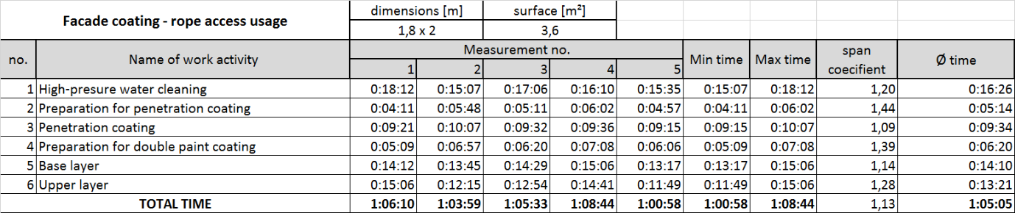Figure 1: Time consumption measurement (source: authors)

Calculation of unit price

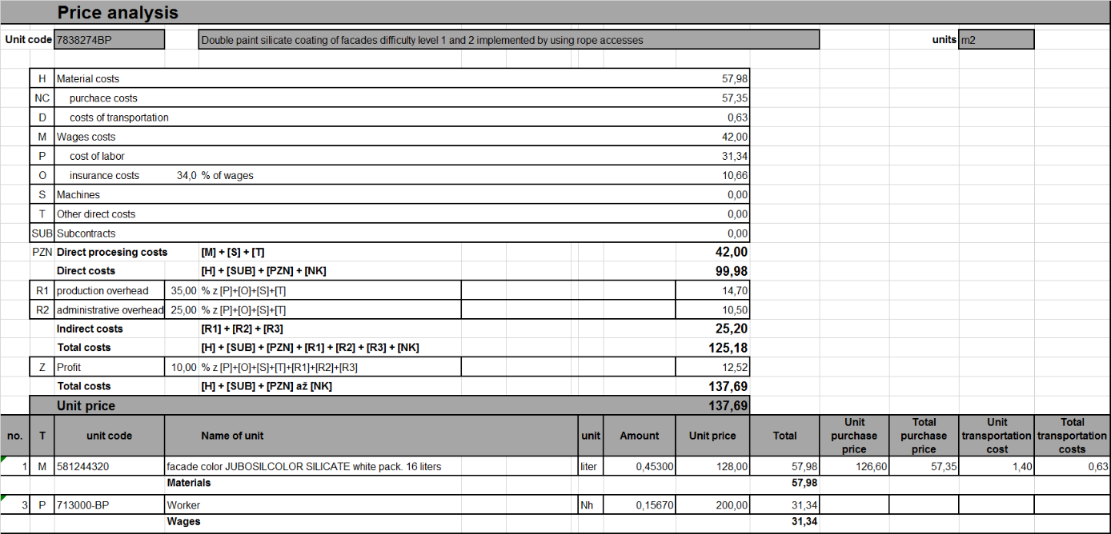New items of price systems have been made, specifically by measured activities and used materials. Thus, only a limited set of new items has been created, for example the silicate painting has been applied to the facade coating, so new items cannot be created for other types of coatings. Similarly of other items. It can be estimated that, for example more extensive repairs will be cost-intensive or time-consuming, or vice versa. [3] But it is speculation and the creation of these other items is left to further professional work on the subject. The new unit prices have been processed into transparent analysis sheet, as is the case of all items in the price system. In these sheets it’s easy to see the calculation formula used to calculate the individual price components.

Figure 2: Price analysis sheet (source: authors)

Case Studies

Achieved results in form of unit prices have been used for tender procedure in real construction environment. It was two construction sites where time consumption measurements have been done. Valuation has been done for both methods although only the method of rope accesses was really used. Detailed bid budget is presented at first case study for better explanation. Results of these two case studies are the answer for the frequently asked question of choosing the best method of approach for high-rise work activities.

Case study A – repair of apartment building facade

This study was focused on construction works including repairs and coating of courtyard facade of apartment building in Holešovice in Prague. Damage was in scale of 30% of surface. Due to complicated garden modifications and presence of cellar skylights, scaffolding cannot be used, so the work was done using rope accesses.

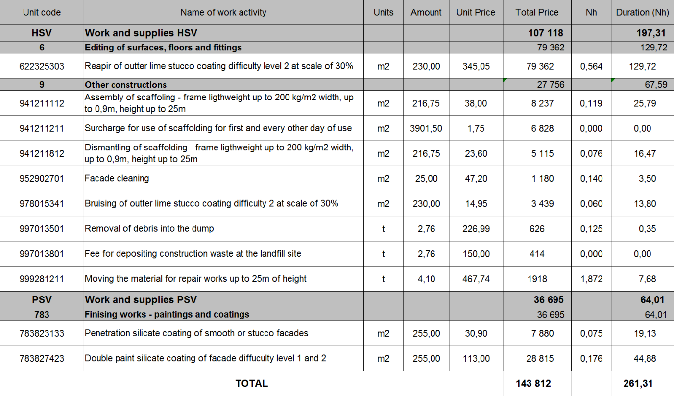

Figure 3: Bid budget - scaffolding usage (source: authors)

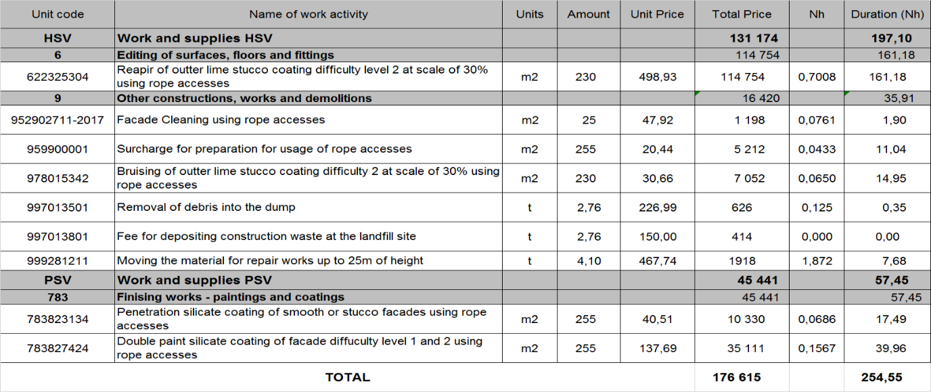First chart present simulated bid budget for scaffolding usage, where you can see all work activities, their acreages and respectively unit prices. Chart is also extended by column of time consumption, just to show how long would works take. Same pattern is used in second chart presenting bid budget for rope access method.

Figure 4: Bid budget - rope accesses usage (source: authors)

We can simplify these two comprehensive charts into price graph, because difference in time consumption is not so significant.

Figure 5: Bid budgets comparison (source: authors)

Comparing two methods we can see notable difference of prices. Higher price at rope access work activities is consequence of bigger time consumption and higher wage rate. From the financial point of view, it is therefore better to perform facade repairs in classic way using scaffolding. In terms of time, the work activities itself are advantageous if done also in classic way. However assembly and dismantling of scaffolding prolong the total duration of works so the difference between two methods is minimized leaving the first method slightly better. It should be noted that with the increasing range of work, the time difference would increase again and so advantageous of using scaffolding would be significant in both respects of time and finance. Even under the assumption of paying for annexed space of street into construction site if works would be realized on street-façade.

Case study B – coating of apartment building facade

In this case, it was a contract for cleaning and subsequent coating of a street facade in city center. Work was done using rope accesses. Implementation costs have been increased due to the need of construction site for safety and practical reasons.

Figure 6: Price comparison (source: authors)

Comparison in this case study provides completely different results than before. Work activities realized by using rope accesses are way advantageous in both respects of finance and time. Main factor is time consumption, as we can see in charts.

Figure 7: Duration consumption (source: authors)

Method of using scaffolding is much more time demanding therefore whole construction takes more time so does need for construction site on the street. While using rope accesses is need for construction site only during work shift, in case of scaffolding it is whole day including nonworking days (weekends). For practical reasons was decided that the second working week would be works implemented also on Saturday. That shortened the occupation of street by two nonworking days. Nevertheless, the difference in the cost of annexed street space is almost double. The main price difference, however, is the price for use of scaffolding, which also exceeds the slight difference in price when comparing only work activities itself. In terms of finance and time is therefore more advantageous usage of rope accesses.

Conclusion

The new created unit prices for construction works using rope accesses have been assessed in the case study with their counterparts for scaffolding usage. Results of this case study are several. Whereas in the implementation of repairs associated with the coating of the facade, the classic way of using scaffolding is cheaper and less time-consuming due to lower time-consumption standards, lower wage rates and thus lower unit prices compared to the use of rope accesses. Otherwise, implementing only the facade coating, we observe lower both time and financial difficulty of work activities. The reason for this is the lower consumption of time, which is surprising, because in the first study it was so that works implemented by using rope accesses lasted longer. The main reason is the absence of scaffolding and costs and time consumption associated with it. Therefore, the use of rope accesses is more appropriate for facade coatings, although there is a slightly higher unit cost of partial activities due to higher wage rates, but significantly less time consuming.

Acknowledgements

This work was supported by the Grant Agency of the Czech Technical University in Prague, grant No. SGS17/025/OHK1/1T/11.

References

1. SCHNEIDEROVÁ HERALOVÁ, Renáta, Anna KADLČÁKOVÁ a Lucie KREMLOVÁ. *Kalkulace a nabídky 1*. Praha: Nakladatelství ČVUT, 2006. ISBN 80-01-03532-8.
2. Ma, L., Zhang, W., Fu, H., Guo, Y., Chablat, D., Bennis, F., Sawanoi, A. and Fugiwara, N. (2010), *A framework for interactive work design based on motion tracking, simulation, and analysis*. Hum. Factors Man., 20: 339–352. doi:10.1002/hfm.20178
3. ÚRS Praha, a.s. *Příručka rozpočtáře: rozpočtování a oceňování stavebních prací*. Praha: 2017. Cenová soustava ÚRS.