Construction Maeconomics Conference 2017

Smart Prague – Energy Ecosystem

Michal Rohlena1, Jana Frkova2

1Faculty of Civil Engineering, Czech Technical University in Prague, Thakurova 7, Prague, 166 29, Czech Republic, michal.rohlena@fsv.cvut.cz

2Faculty of Civil Engineering, Czech Technical University in Prague, Thakurova 7, Prague, 166 29, Czech Republic, frkova@fsv.cvut.cz

Abstract

The article deals with the introduction of the energy ecosystem of buildings owned by the Capital City of Prague. Prague owns almost 1600 buildings. These buildings also have a different character of use, such as offices, schools, social care homes, etc. All these buildings consume energy that needs to be monitored and regulated. When planning building revitalization, it is necessary to have sufficient information for qualified decisions that buildings have the greatest potential for energy savings, operating costs and Co2 emissions. However, the energy ecosystem that is being prepared needs a large amount of relevant data on these buildings. It is necessary to know the technical state of the building, energy systems and data on operating costs. Based on multi-criteria decision-making, it is possible to choose suitable buildings for thermal insulation, power exchange, energy management and other measures leading to savings in energy consumption and operating costs. These saved resources can then be re-invested in other buildings and can use other funding options.

Keywords

Ecosystem, Smart Prague, Cost, EPC, buildings, energy

Introduction

The European Union (EU) leads a worldwide struggle against climate change and considers this as one of its highest priorities. The 2030 climate and energy framework sets three key targets for the year 2030:

* At least a 40% cut in greenhouse gas emissions (from 1990 levels)
* At least a 27% share for renewable energy
* At least a 27% improvement in energy efficiency. According to the Joint Research [1]

Centre (JRC, 2013) (further only as JRC) the building stock represents 40% of the European Union’s final energy consumption. Directing requests for savings to the buildings category is thus justified (Directive 2002/91/EC). The saving energy policy is gradually being transferred to local administrations (Directive 2010/31/EU). Given that more than 80% of the population live in cities, this transfer of responsibility is justified. Local administrations have most possibilities to influence energy consumption on their territory and on their primary resources. On the basis of its own behaviour the local administration then influences the behaviour of its own citizens. The concept Smart Cities is currently gaining increasing attention.

A more conceptual and coordinated approach to solving problems on any territory with a high concentration of population, transport, energy consumption, waste production etc. can be very effective. Integrated projects which can be implemented by means of various coordinated instruments have just the kind of substantial potential required for necessary creative synergies. An integrated combination of support across an energy efficiency area, ICT and transport - so called Smart Cities - or indeed other interventions put in place on the basis of a coherent set of goals in an area, can provide such an example of significant synergy.

The capital city of Prague adopted the concept smart cities, because in connection with current technologies it is possible to create a smart city in lifelong terms and at the same time to reach the required energy savings.

Definition of the term Smart Cities

Currently *smart cities* has great topicality and is widely discussed among professional communities and there are many publications on this matter. (Townsend 2013, Thoumi 2013, Kumar 2014, Araya 2014, Brook 2013, Hollins 2013, Montgomery 2013, Smith 2012)

In the professional literature we can find multiple definitions of the term *Smart Cities*. Let us introduce two here, the first one representing a more academic view and the second one more recognizable to the general public:

* “A city is considered smart when investments in human and social capital and traditional transport and modern (ICT) communication infrastructure generate sustainable economic growth and a high quality of life, overseen with a wise management of natural resources, through participatory governance.” [2]
* The second definition is presented by the climate strategist B. Cohen: “Smart cities use information and communication technologies in order to be more intelligent and efficient in the use of resources, resulting in cost and energy savings, improved service delivery and quality of life, and a reduced environmental footprint--all supporting innovation and a low-carbon economy.” [3]

Energy ecosystem of buildings in the concept Smart Prague

The main objective of energy management is to improve energy-related performance and energy efficiency continuously and to identify energy reduction opportunities. This systematic approach will help organizations to establish systems and processes.

Consistent energy management helps organizations to realize untapped energy efficiency potential. They will benefit from cost savings and make a significant contribution to environmental and climate protection, for example by the permanent reduction of CO2 emissions. The standard should alert employees and in particular the management level to the immediate and long-term energy management gains that can be made. The organization can discover potential savings and competitive advantages. Furthermore, a huge image boost for municipalities can be brought about. [4]

Local administrations own and use a large number of buildings. These buildings have different types of use, and they are of different age, structure, and technical condition. In all these buildings there is energy consumption which has to be monitored and regulated. When planning the revitalization of buildings it is necessary to have enough information for a qualified decision on which buildings have the highest potential for energy savings, along with lower operational costs and CO2 emissions. Relevant data is not accessible or mutually interlinked without the introduction of deliberate energy management. Thus there occurs rather pointless spending of financial means for the reconstruction of buildings with low potential for energy savings, reducing operational costs and CO2 emissions.

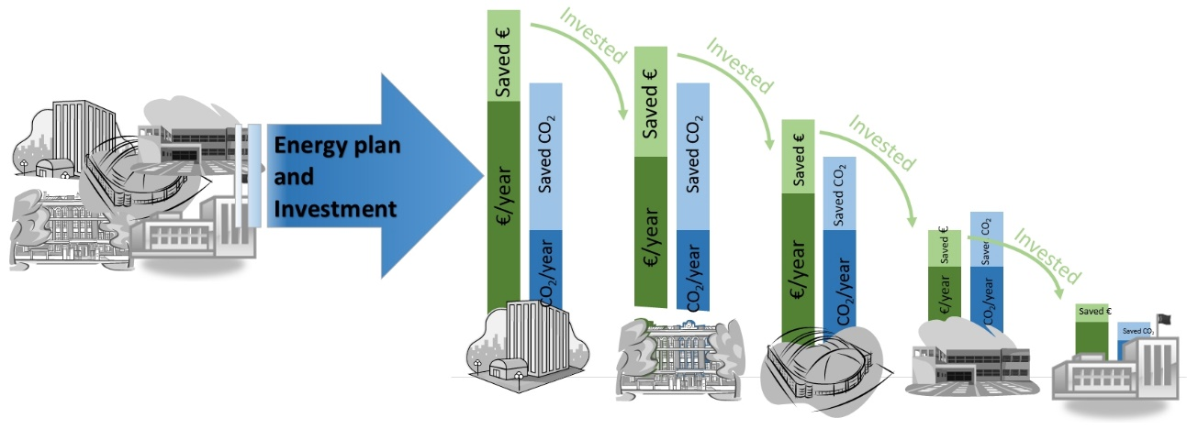

Figure 1: Diagram of an established energy management system (source: authors)

The primary impulse for introducing energy management has to be (leaving aside other things) setting out political objectives in energy consumption reduction and CO2 emissions production. On the basis of this stated objective it is possible to introduce serious energy management, bringing with it also the benefit for the city in reducing operational costs.

Introducing energy management enables optimal use of financial means invested into buildings with a high savings potential. The savings from reduced operational costs for various forms of energy can be consequently used for energy safety measures in other buildings as represented in Figure 1.

Introducing energy management of buildings can be described in 4 basic steps:

* Collection and aggregation of existing data
* Definition of the methodology for the evaluation of buildings
* Implementation and Operation
* Definition of the system for financing

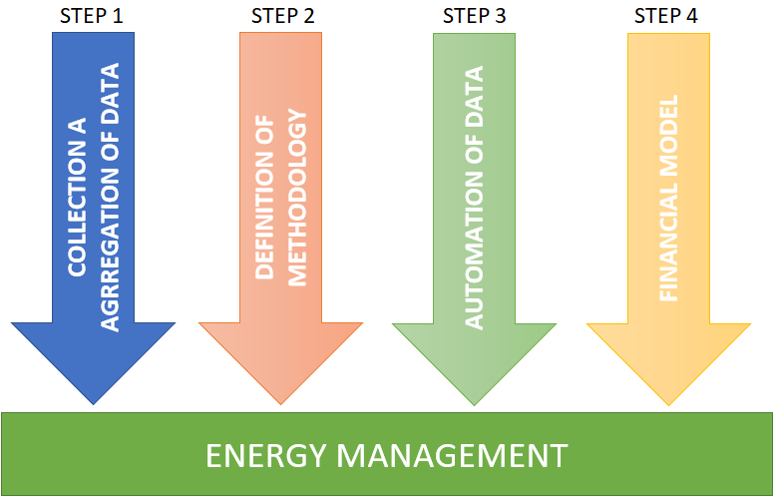

Figure 2: Scheme for introducing energy management of buildings (source: authors)

STEP 1 – Collection and aggregation of data

The first step is the analysis and aggregation of accessible data on buildings. It primarily concerns:

* The way the building is used
* The structural system and the technical condition of a building
* Included technical systems which consume energy
* Data on energy and water consumption
* Operational costs for energy and water consumption

It concerns data which currently do not need or have a sufficient structure to them and are thus not directly interconnected with all deployed information systems.

STEP 2 – Definition of methodology

In the case of a very large number of owned and used buildings it is neither possible to set optimal saving measures nor to determine on which buildings to implement it. Therefore it is necessary to set the methodology towards what way the buildings will be estimated and what impact the saving measure will have in meeting the stipulated objectives.

On the basis of accessible data the methodology should categorize buildings according to the suitability of measures for the given building.

In a simplified way it concerns the following categories:

* Thermal building sheathing
* Change and regulation of technical systems
* Complex revitalization of a building

The evaluation must take into consideration a large number of criteria including e.g. :

* Current energy consumption
* Technical condition of a building
* Technical condition and age of technical systems of a building
* Limiting factors – e.g. preservation of monuments

STEP 3 – Automation of data collection

The next step towards introducing energy management is creating a data platform into which all new available data on buildings will be automatically stored. Primarily it concerns the data on energy and water consumption and appropriate costs. These data will be monitored and automatically recorded. These data will serve for the regular evaluation of the benefits from saving measures and for further continuous improvement according to the processes Plan – Do – Check – Act.

It is further appropriate to replenish technical data, project documentation and other documents connected with particular buildings.

STEP 4 – FINANCIAL MODEL

The introduction of a financial model is an inseparable part of energy management. Capital city of Prague have to manage with limited financial means. Traditional but also innovative financial tools are part of financial resourcing.

* Own budget
* Credit
* Subsidies
* Reinvestment from achieved savings
* EPC

An EPC is a partnership between a municipality and an energy service company. The energy service company conducts a comprehensive energy audit for a municipal facility and identifies improvements that can save energy. In consultation with the municipality, the energy service company designs and devises a project that meets the agency's needs and arranges the necessary financing. The energy service company guarantees that the improvements will generate energy cost savings sufficient to pay for the project over the term of the contract. After the contract ends, all additional cost savings accrue to the agency. [5]

Conclusion

Municipalities are responsible for reducing energy consumption and CO2 emissions. This responsibility is delegated to them from the European Union because 80% of the population live in cities and thus they possess the most possibilities to influence the behavior of the inhabitants. Dealing with their own property in an exemplary fashion, the municipalities can set an example to the inhabitants. The concept Smart Cities is driving an increasing trend where, by using accessible technologies, it is possible to create a city that is thinking smart for the life of its inhabitants and at the same time to achieve the energy savings that are much sought. The City of Prague adopted the concept of smart cities and is preparing an energy ecosystem project of buildings.

The energy management of buildings is one part of Smart Cities. Buildings consume 40% of energy and thus they have a high saving potential. One problem is the large number of buildings and their variety of use. On the basis of a multi-criteria evaluation it is thus necessary to differentiate suitable buildings for individual saving measures. It is the only way to find out how to maximize the benefit from implemented measures even under the limited financial means which the city of Prague can disburse. For the implementation of municipal saving measures there is a need to use not only traditional but also innovative financial tools such as e.g. EPC. Along with the introduced energy management it is necessary to further ensure energy efficiency improvement and thus continuously plan and implement other saving measures.

Acknowledgements

This work was supported by the Grant Agency of the Czech Technical University in Prague, grant No. SGS17/021/OHK1/1T/11.

References

[1] European Commission, *Roadmap to a low-carbon economy,* Available from: < https://ec.europa.eu/clima/policies/international/paris_protocol/energy_en> [10 October 2017].

[2] Caragliu, A. et al. 2009. Smart cities in Europe. In *3rd Central European Conference in Regional Science – CERS, 2009*. Faculty of Economics, Technical University of Košice (ed.), Proc. Europ. Conf. Available from <http://www.inta-aivn.org/images/cc/Urbanism/background%20documents/01_03_Nijkamp.pdf > [10 October 2017].

[3] Cohen, B. 2012. *The Top 10 Smart Cities On The Planet 2012*. Available from <http://www.fastcoexist.com/1679127/the-top-10-smart-cities-on-the-planet> [10 October 2017].

[4] *ISO 50001 Energy management*

[5] U.S Department of Energy, (2011, February 04). *Energy Savings Performance Contracts*., Available from <http://www1.eere.energy.gov> [15 October 2017].