Construction Maeconomics Conference 2017

Procurement selection as a part of strategic planning

Ing. Harry Löwit1

1CTU in Prague Fac. of Civil Engineering, Thákurova 7, Praha 6, 166 29, Czech Republic, harry.lowit@fsv.cvut.cz

Abstract

The construction project realization is really complicated - especially for the owner. Owner’s main goal is to realize a project, according to his demands, according to time schedule and with reduced cost if possible. At the beginning owner needs to define his strategy for the project realization and choose procurement system. That means to create a project organization, identify project partial goals and determine possible risks. Risk management is also necessary. During this project phase many risks occur but they can be handled by the appropriate attitude

The whole strategy process is affected by the needs of the owner and the abilities of the potential contractors and project team. Nowadays, project strategy is still affected by adversarial surroundings on the Czech construction market. In many cases the owner is deprived of the possibility to elect the optimal way to realize project losing its potential advantages and possibly accepting more risks than necessary. Establishing the project realization strategy and procurement system selection are very often underestimated. but it is a very useful tool for the successful project realization. The appropriate strategy should enable the owner an easier preparation and realisation of the construction project.

Keywords

Construction project; procurement system; owner´s strategy; strategic planning

Introduction

Strategy of the projects realization is ground-work for victorious project in civil engineering. Construction projects are very specific, almost every construction project is original. These projects are affected by many subjects and situations on the construction market. The whole construction market is developing rapidly and changes its old-fashioned attitude. Nowadays it’s not separate entity, but it is a part of the global interactions. Many different subjects with many different capacities are involved in the present-day construction industry business to develop and deliver final product according to the demands [1].

Since the main goals of the project are defined, strategy is the methodology to achieve these goals. It doesn’t matter in which construction area is company involved, strategy is a basic tool to reach the company goal and key to the successful project realization. There is not clearly defined a difference between project strategy stage and feasibility study stage on the Czech construction market. The main role of each project phase is very close to each other and activities during these two phases are nearly similar [2]. The main reason is that both are affected mutually by partial standards and findings. These two stages go parallelly and their connection is absolutely necessary for the effective results of every stage and for the project completion as well. Feedback is the main topic in these stages, as a crucial owner’s tool for early decision making and subsequently realization of these decisions.

The paper concerns on procurement selection as a part of the strategy planning as a vital function of the project realization. The most experienced managers are chosen for these jobs and they are responsible for the fluently project realization. Strategy planning basically depends on the company size and branch of the business. One part of specialists sees strategy planning as a huge complicated science. In the other extreme, managers don’t think about strategy planning – it just exists. Generally, strategy planning is about situation analyze, named factors affecting project and company, find and solve problems.

Methodology details

There is more than one way to pick the most suitable research method. There is the possibility of choosing a mixed method, combining the advantages of each individual approach while eliminating their weak points.

For this work, qualitative research was selected and applied as a suitable technique for data collection. This type of research can deal with the description of processes, relations, situations and could increase the understanding of the topic. There are possible positivist and phenomenological research methods. The phenomenological method is based on a description, translation and other studies of certain phenomena [3] and an assumption of empirical knowledge. The phenomenological research method seems more suitable for this work instead of the positivist method, which has more philosophical approach and the type of knowledge is based on statistical logic [4].

For the data collection, interviews with the clients, contractors and legal professionals were made and surveys were used as well. The research aim of this work is to demonstrate the differences in particular approaches. The author also reviewed several case studies of the project delivery for this research, because that is the best way to approach qualitative research as a detailed study of one or a few cases [5].

Academic literature, case studies and interviews were the main sources of data.

Project strategic planning

Project strategic planning procedure is one phase of the project. Graphically project phases are shown below, but the sequence is not untouchable and could be different for each project, according to the project demands [2].

Strategic planning could be divided into five steps [6]:

* Methodology of strategic planning
* Company mission
* Business environment
* Analysis of company’s resources
* Competitive strategy development

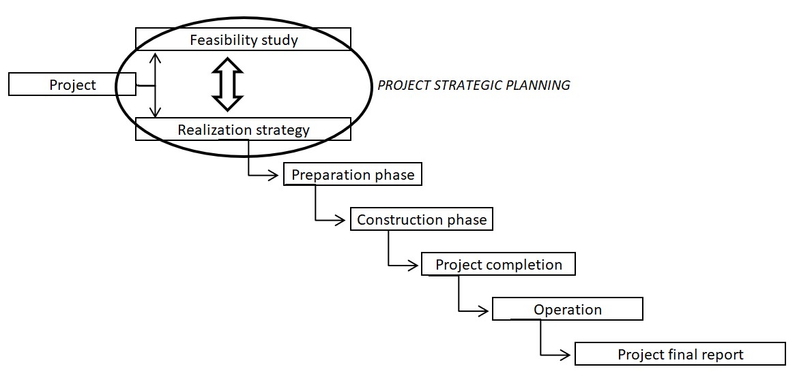

Figure 1: Phases of the project development

Methodology of strategic planning

First basic step, before planning could be start, is to define and clearly formulate the basic problems. This could be done by the analyses, and its procedure contains:

* Problems definition. Define inputs, outputs and possible solutions.
* Define the parameters of the expected best solution.
* Formulate the procedure how to reach the expected solution. How could be inputs effectively transformed to the outputs.
* Try to find most favorable solution with maintaining main parameters for the optimal balance.

Company mission

In these step, company mission is defined. The company mission involves company scope of the activities and company objectives.

The scope of activities engaged the type of the projects that company want to realize. Construction companies are very often specialized to unique construction sector, e.g. roads, bridges, offices, etc. According to the company size and affected sector, it’s necessary to point out what type of client company prefer. The scope of activities also considers the future project location. Small companies are often limited by the specific region, while larger one can operate through countries and markets.

Company objectives set the major goal of the company business and determines the measurement of the company success. To increase the size of the company, wide range goals are often determined. For the particular aim, partial goals are set, because they could be realized in shorter time period with better comparable parameters, e.g. profitability.

Business environment

Studies of the business environment are essential input for this step. From these studies construction company obtain information about opportunities and possible threats, that should be carefully observed. Main topics of these business environment studies are future infrastructure deals, new buildings demand in the region of interest, survey competitors, macroeconomics indicators and production factors, etc.

Future plans come simultaneously with business environment studies. Bigger construction companies are used to work and plan in five years perspective.

Analysis of company’s resources

The company ability to be competitive on the construction market in principal depends od company own resources. Company is generally explored from this point of view. The two main types of resources are: resources as a part of the production chain, resources supporting first group. In the construction company those resources in the production chain are construction capacity, procurement and marketing. Inputs are directly transform to outputs and effective transformation lead to successful project and company profit is made by these resources. Supporting resources are company organization, employees, finances and know – how. These are important as well, because they support production chain to gain maximum efficiency.

Resources analyze is very significant. Know about the company strengths and weaknesses provide advantage in planning. With these information is possible to remain competitive and utilize company advantages in the business.

Competitive strategy development

With four steps of the strategic planning mentioned above, company management has enough information and inputs to develop company competitive strategy. This strategy development contains three major parts:

* Summarize conclusions from the inputs – analyses of the construction market, company, its business environment, etc.
* Develop and select optimum strategy to be competitive on the construction market with the other competitors.
* Select optimum strategy to maximize utilization of the own company resources.

For both strategies, the analyses of the company and its business environment provide valuable information. The analyses reveal companies’ weak points, company opportunity and as a most important, the current situation on the construction market. With these inputs strategy selection could be done.

Plenty of alternative strategies exist to be adapted and used on the specific project in different construction areas with different company attitude.

Procurement system selection

This phase of the project strategy planning could be apprehended as a part of a competitive strategy development for the construction project realization. In this phase all needs and requirements for the realization phase should be determined. The strategy of procurement tries to influence questions about the options of purchase, storing and expediting. The field of procurement is of high significance in the business of construction companies; it’s largest expenditure. A good strategy in this area makes it possible to create great savings; that seriously can increase the total profit [7].

The outcoming project has to be as good as possible, according to time delivery, total price and project quality. Time schedule is agreed between involved parties, but delays occur quite often. Every small mistake or miscalculation can affect the realization time and could negatively affect project realization time. Typical reason for stretched project schedule is subcontractors delay. If the project won’t be realized in time, it will raise project costs and decrease profit. Company reputation will be affected as well. Managing a successful construction company is generally about ability to get suitable type of projects.

The complexity assessments provide a consistent and structured basis to evaluate the organization and the project. When used in conjunction with the capability assessments, they provide a fuller picture of the capability of each party to deliver the chosen procurement strategy effectively. This ensures that selection of the procurement strategy is made with a full understanding of the risks and opportunities that may affect successful delivery. To assist in the selection of the appropriate delivery or procurement model, the different approaches are used (e.g. Transactional, Critical, Leveraged or Strategic). These are not definitive categories and broadly represent different approaches to the complexity and risk allocation [8].

The range of used procurement systems is very wide. In practice, many variations are possible in developing a delivery and procurement model to fit the project requirements. The ideal procurement system has to protect owner’s interest and demands. The differences in procurement systems cover different risk allocation and project member’s liability. The procurement system selection affects total price of the project too. Project manager prepares materials and pros and cons for each possible procurement system. Clear goal is to maximize owner’s profit on the project.

Nowadays several types of procurement systems are used in civil engineering. On one side, there are still traditional procurement systems, e.g. Design – bid – build, nevertheless, there are more and more alternative systems used such as Design – build, ECI, PPP or PFI projects. Compared to the UK and the US, Czech construction market falls considerably behind with these alternative types of the procurement systems. The alternative types of these systems emerged in the US in the 80s and during 30 years the Design – build system has become more popular than the traditional ones [90]. The popularity of the alternative Design-build system gradually growths as opposed to the gradual fall of the Design-bid-build. Nowadays, the former is used for more than one half of the US construction projects [10].

Generally, the possible basic procurement systems areas are:

* Traditional procurement systems – Design-bid-build, etcc.
* Integrated procurement systems - Design build, PFI projects
* Independent procurement systems – Partnering, Joint venture, Alliance, etc.
* Project management

Conclusion

This paper was designed to show connection between project strategic planning and procurement system selection for the construction projects. Construction projects tent to be more complicated nowadays, because of the complexity of modern projects. Construction industry itself still remains adversarial with force relationships among involved parties. In order to achieve successful project realization, there must be chosen optimal procurement system and developed project strategy.

This topic is still very underestimated part of project development. These attributes are still missing on many construction projects on Czech Republic construction market. In a fact, this phase is one of crucial phases in the project. If processes carefully, the project realization strategy – as a result of the strategic planning - could simplify following project phases, but mainly, it should save total costs and time of the realization.

There is no one universal strategy or system how to select optimal procurement system and realize construction project. Every procurement system has pros and cons; every project needs individual strategy for realization. Using of the impropriate procurement system contributes to increasing risk and number of disputes in addition to the existing ones. Because every project is unique, it is just possible to summarize and indicate partly advantages and disadvantages in single strategies and systems. Generally, more complicated project needs more emphasis on project strategy, procurement system selection, mutual contractual relationships and risk allocation [11].

Nevertheless, that attitude is necessary for successful project realization with well planned projects, balanced contracts, less risks, disputes and time and costs overruns. Based on research, e.g. interviews executed with business professionals and a review of academic literature, the work tries to identify a few factors of successful project strategy implementation:

* Proper analyses of the market and own company as well
* System for risk interpretation and management is necessary
* Select suitable procurement system – easier one is better

References

1. RAMEEZDEEN R., RAJAPAKSE CH. *Contract interpretation: the impact of readability.* Construction Management and Economics, 07/2007, 25, pp729 – 737.
2. LÖWIT H. *Establishing owner’s strategy on the construction project realization.* Construction Maeconomics Conference 2015, Prague, Czech Republic, 2015.
3. Copper, D.R., Schindler, P.S.: *Business Research Methods (9th edition)*. Singapore: Mc. Graw Hill, International Edition, 2006.
4. SILVERMAN, D. *Qualitative Methodology & Sociology.* Aldershot: Gover Publishing, 1985.
5. Yin, R. K.: *Case Study Research: Design and Methods*. Thousand Oaks, USA: Sage Publications, 2009.
6. Warszavski A.: *Strategic Planning in Construction Companies.* Journal of construction engineering and management, 06/1996.
7. Gustafsson J.: *Analysis of procurement in construction companies - a part of strategic planning*. KTH, Stockholm, Sweden: Economics and Management 30, 2008.
8. HM Treasury: *Sourcing Focus.* Retrieved 10 11, 2013, from Sourcing Focus the portal for the sourcing industry. 2013
9. Löwit H., Dostálová M.: *Defining of decision-making criteria for optimum contractor system selection for public works*. Proceedings of the Creative Construction Conference 2014, conference, Czech Republic, Prague, 2014.
10. Darren R. Hale, Pramen P. Shrestha, G. Edward Gibson Jr., Giovanni C. Migliaccio.: *Empirical Comparison of Design/Build and Design/Bid/Build Project Delivery Methods,* JOURNAL OF CONSTRUCTION ENGINEERING AND MANAGEMENT, 2009.