Construction Maeconomics Conference 2017

COMPARATIVE COST ANALYSIS BETWEEN GREEN ROOFS AND TRADITIONAL ROOF SYSTEMS IN THE CZECH REPUBLIC

Šárka Konášová

CTU in Prague, Faculty of Civil Engineering, Thakurova 7, Praha 6, 166 29, Czech Republic,   
sarka.konasova@gmail.com, (tel. +420 724 503 591)

Abstract

Keywords

comparative cost analysis; green roof, traditional roof system,

Introduction

The world's urban population grows, each year tens of millions of people move from rural areas to cities, creating the greatest influx ever of people into urban areas [1]. Urbanization itself is not necessarily a problem. Nevertheless, one of the negative impacts of urbanization is that it creates many impervious surfaces, which lead to faster runoff from land and reduce the natural cooling effects of water on the landscape. More importantly, the lack of vegetation means less evapotranspiration, which naturally helps to cool surfaces and air temperatures. The use of vegetation in the urban environment brings many benefits beyond improved quality of life. Therefore, it is necessary to promote the use of new green technology and seek solutions in renewable materials to mitigate a variety of urban environmental impacts. One of the most tangible elements of sustainability strategy are green roofs.

Sometimes, green roofs are considered as environmental innovation. It is true that in efforts to address the current state of the environment, especially in cities, they are a relatively new phenomenon. However, as an architectural element, they have been known for a long time. Green roofs are quite possibly uncommon for the public, because they do not have a well-known tradition (unlike e.g. from Scandinavia). In spite of this, modern architecture is rediscovering them in a new light and they grow in popularity not only in the Czech Republic, but also abroad. According to many experts, green roofs provide the benefits that contemporary urban areas may use to improve their environment. Moreover, they return nature to the cities and ultimately it is their aesthetic value, where many people find them attractive

# Purpose

The aim of this paper is to compare the costs of green roofs to conventional roofs and demonstrate that costs of green roofs are not significantly different to traditional ones. This requires an understanding of costs of green and conventional roofs, a comparison of these costs, and an analysis of the results. This analysis gives a financial overview of a green roof as an alternative option for roofing systems. Building owners typically choose to make investments with the lowest price without considering sustainable profit on investment with the non-financial benefits such as environmental and social benefits.

Method

The comparative cost analysis presented in this section is based on a direct comparison between the costs of traditional roofing systems used in the Czech Republic and green roof systems. The work is divided into two main steps. Firstly, the constructions techniques and details of roofs are defined. Secondly, the total costs of each roof system are computed from obtained data.

**Construction techniques**

For the elaboration of the comparative analysis of roofing systems, the systems that would be adopted for the identical family house with a ground area of 96 m2 is initially defined (Figure 1). There are defined two systems for conventional roof, which are Czech's traditional systems, single-ply roofing systems of asphalt and gravel and pitched roof with ceramic tiles. For extensive green roofs, two variants of construction systems with different layers from Optigreen, which is a reputable supplier the green roof systems, are also used.

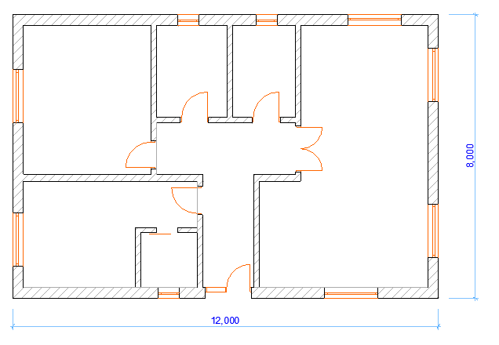

Figure 1: The layout of family house, Author

* A. Single-ply roofing system of asphalt and gravel

The first system chosen for comparison is the single-ply roofing system of asphalt and gravel, (Figure 2). It is a classic composition of flat roofs, where thermal insulation is placed under the waterproof layer. A vapour barrier layer is used in case when the relative humidity in the interior exceeds 60%, because waterproof layers have higher diffusion resistance (the ability to transmit water vapour), which could lead to condensation of water vapour permeating in the winter from the interior to the exterior of the building through the roof. Originally, asphalt roofing required a layer of gravel above it for two reasons. First, asphalt with direct exposure to sunlight degrades much faster, mainly because of the expansion and contraction throughout the day. Secondly, asphalt needs weight above to hold it down, because it sits on the top of a building, instead of being attached to it.

|  |  |
| --- | --- |
| **Layers of single ply roofing system** | |
| 1 | Layer of gravel |
| 2 | Modified Bitumen |
| 3 | Thermal insulation - EPS |
| 4 | Vapour barrier |
| 5 | Roof coating |
| 6 | Suitable substructure |

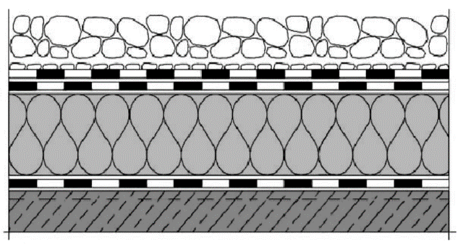

Figure 2: Technical specifications of single-ply roofing system of asphalt and gravel [2]

* B. Pitched roof with ceramic tiles

The standard composition of pitched roofs with ceramic tiles is based on the insertion of a thermal insulation material between the rafters (Figure 3). It always consists of a layer of waterproof membrane, thermal insulation, which is exclusively based on mineral wool, and interior vapour barriers. This composition is characterized by two ventilated air gaps generally located between thermal insulation and hydro insulation under the ceramic tiles.

|  |  |
| --- | --- |
| **Layers of pitched roof with ceramic tiles** | |
| 1 | Ceramic tiles |
| 2 | Roofing battens |
| 3 | Ventilated space |
| 4 | Hydro insulation |
| 5 | Air gap |
| 6 | Thermal insulation - mineral wool |
| 7 | Vapour barrier |
| 8 | Suspended ceilings |

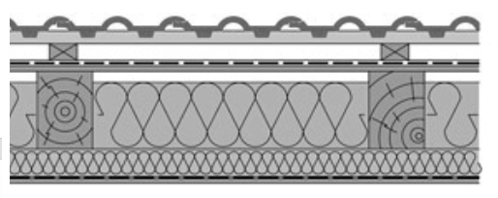

Figure 3: Technical specifications of pitched roof with ceramic tiles [3]

* C. Green roof - Optigreen "economy roof" system solution

Optigreen economy roof is cost-efficient green roof structure in terms of material, installation and maintenance care (Figure 4). It has relatively low maximum weight, as little as a gravel roof. The pre-cultivated vegetation mats are used, which provide immediate surface finalization and an instant coverage of approx. 80 – 100%. These vegetation mats are installed on the finished layer of extensive substrate and are available with several species compositions, consisting of sedum, grasses and herbs [4].

|  |  |
| --- | --- |
| **Layers of economy roof system solution** | |
| 1 | Optigreen Pre-cultivated Sedum Vegetation Mat |
| 2 | Optigreen Extensive Substrate Type E (80 mm) |
| 3 | Optigreen Filter Fleece Type 105 |
| 4 | Optigreen Drainage Board Type FKD 25 (25 mm) |
| 5 | Optigreen Protection and Storage Fleece Type RMS 300 |
| 6 | Waterproofing membrane |
| 7 | Suitable substructure |

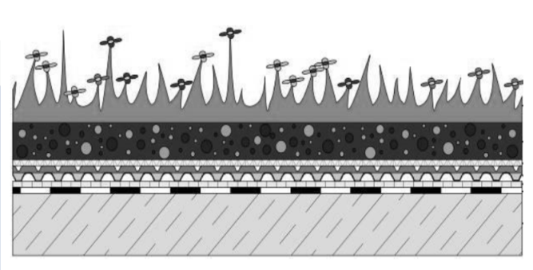

Figure 4: Technical specifications of economy roof system solution [4]

* C. Green roof - Optigreen "lightweight roof" system solution

Optigreen lightweight roofs are the lightest green roof solution from Optigreen with special construction design (Figure 5). This system is recommended for the underlying structures, which permit only a light load, because system weighs only about 50 kg/m2 even in saturated conditions, making it half as heavy as a conventional gravel roof. It can also be used for non-pitched roofs without deep puddles forming. The system is available with automatic irrigation systems for dry regions [4]. In comparison to Optigreen economy roof system solution, it requires increased maintenance. The vegetation used with this system solution is delivered as a pre-cultivated vegetation mat, which is composed primarily of a combination of various sedum and mosses.

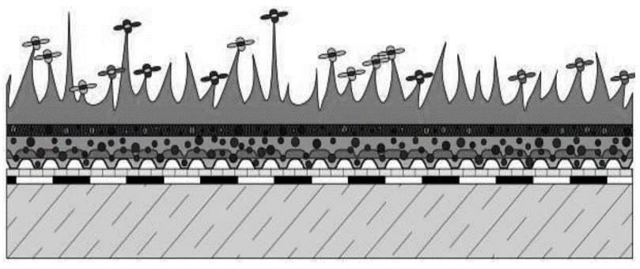

|  |  |
| --- | --- |
| **Layers of lightweight roof" system solution** | |
| 1 | Optigreen Pre-cultivated Sedum Vegetation Mat |
| 2 | Optigreen Low Density Substrate (50 mm) |
| 3 | Optigreen Drainage Board Type FKD 25 (25 mm) |
| 4 | Optigreen Protection and Storage Fleece Type RMS 300 |
| 5 | Waterproofing membrane |
| 6 | Suitable substructure |

Figure 5: Technical specifications of lightweight roof system solution [4]

**Data analysis**

Data analysis was conducted by the comparison between the data obtained from each of the roof composition. The analysis of the costs of all four types of coverage is presented in form of tables. Single-ply roofing system of asphalt and gravel and both green roof systems were calculated to 96 m2 of roof area.In the case of pitched roofs with ceramic tiles, a slope of the roof had to be taken into consideration. For this type of house, a pitch 4/12 and a roof overhangs 250 mm was chosen. The estimated roof area of pitched roof is 105.14 m2. To compute the total costs of each roof system, the variable cost per unit was multiplied by the actual production volume. Only the costs of roof system’s materials were calculated, without taking into consideration the costs of labor, equipment, overhead and profit. The costs of each material were determined by the demands of the individual companies, which sent their quotes.

* A. Single-ply roofing system of asphalt and gravel

The material costs of single-ply roofing system are presented in Table 1. The costs of this type of roof system are 1 391 €.

Table 1: The material costs of single-ply roofing system, Author

|  |  |  |  |  |
| --- | --- | --- | --- | --- |
| ***Single-Ply Roofing System of Asphalt and Gravel*** | Quantity | Unit | Cost [€] | Total Cost [€] |
| Layer of gravel 60mm | 3,60 | t | 7,53 | 27,11 |
| Modified Bitumen | 96,00 | m² | 5,26 | 504,96 |
| Thermal insulation - EPS 100 S Stabil 160mm | 96,00 | m² | 7,45 | 715,20 |
| Vapour barrier | 96,00 | m² | 0,88 | 84,48 |
| Roof coating | 96,00 | m² | 0,62 | 59,52 |
|  | | | | 1.391,27 |
| **Costs per 1 m²** | | | | **14,49** |

* Pitched roof with ceramic tiles

Table 2 demonstrates the costs of the pitched roof with ceramic tiles. The total costs of this system are 1 959 €. The amount of roofing battens was calculated based on free online software from Zhitov for calculation of pitched roofs [6].

Table 2: The material costs of pitched roof with ceramic tiles, Author

|  |  |  |  |  |
| --- | --- | --- | --- | --- |
| ***Pitched roof with Ceramic Tiles*** | Quantity | Unit | Cost [€] | Total Cost [€] |
| Ceramic tiles Bramac Renova | 105,14 | m² | 6,80 | 714,95 |
| Roofing battens 3000-5000×60×40 mm | 800,00 | m | 0,47 | 376,00 |
| Hydro insulation DEKTEN PRO | 105,14 | m² | 2,15 | 226,05 |
| Thermal insulation - mineral wool ISOVER 140mm | 105,14 | m² | 5,23 | 549,88 |
| Vapour barrier | 105,14 | m² | 0,88 | 92,52 |
|  | | | | 1.959,41 |
| **Costs per 1 m²** | | | | **18,64** |

* Green roof - Optigreen "economy roof" system solution

Table 3 presents the costs of cost-efficient green roof system. Total cost of this system to apply to 96 m2 of roof area are 1 605€.

Table 3: The material costs of economy roof system solution, Author

|  |  |  |  |  |
| --- | --- | --- | --- | --- |
| ***Green roof - Optigreen “economy roof“ system solution*** | Quantity | Unit | Cost [€] | Total Cost [€] |
| Optigreen Pre-cultivated Sedum Vegetation | 5,00 | unit | 26,33 | 131,65 |
| Optigreen Extensive Substrate Type E (80 mm) | 7,68 | m³ | 70,82 | 543,90 |
| Optigreen Filter Fleece Type 105 | 96,00 | m² | 1,02 | 97,92 |
| Optigreen Drainage Board Type FKD 25 (25 mm) | 96,00 | m² | 6,14 | 589,44 |
| Optigreen Protection and Storage Fleece Type RMS 300 | 96,00 | m² | 1,20 | 115,20 |
| Waterproofing Membrane | 96,00 | m² | 1,32 | 126,72 |
|  | | | | 1.604,83 |
| **Costs per 1 m²** | | | | **16,72** |

* Green roof - Optigreen "lightweight roof" system solution

The material costs of lightest green roof solution from Optigreen are presented in Table 4, when total costs of this type of green roof are 1 644€.

|  |  |  |  |  |
| --- | --- | --- | --- | --- |
| ***Green roof - Optigreen “lightweight roof” system solution*** | Quantity | Unit | Cost [€] | Total Cost [€] |
| Optigreen Pre-cultivated Sedum Vegetation | 5,00 | unit | 35,27 | 176,35 |
| Optigreen Low Density Substrate (50 mm) | 4,80 | m³ | 132,45 | 635,76 |
| Optigreen Drainage Board Type FKD 25 (25 mm) | 96,00 | m² | 6,14 | 589,44 |
| Optigreen Protection and Storage Fleece Type RMS 300 | 96,00 | m² | 1,20 | 115,20 |
| Waterproofing Membrane | 96,00 | m² | 1,32 | 126,72 |
|  | | | | 1.643,47 |
| **Costs per 1 m²** | | | | **17,12** |

Table 4: The material costs of lightweight roof system solution, Author

Results of analysis of roof systems

In this part of paper, the comparative analysis of costs of each roof systems is undertaken based on the collected data. There were analyzed four different roof systems in Figure 6 and Table 5, two conventional and two with vegetation cover.

### Figure 6: Costs per 1m2 of different roof systems, Author

According to Figure 6, it can be seen that the single-ply roofing system of asphalt and gravel has the lowest costs per 1 m2, 14.48 €/m² among all analyzed systems. The extensive green roof systems have little bit higher costs in comparison with single-ply roofing system, 16.72 €/m² and 17.12 €/m². The main reason, why green roof lightweight roof system is little more expensive than green roof economy roof, is because of lightweight substrate must be protected against water and wind erosion by pre-cultivated vegetation mats. The most expensive system from this analysis is pitched roof with ceramic tiles. In this case, the costs of this system are relative, because it is difficult to compare construction system of flat roofs to pitched ones considering the thickness of the ceiling structure. All type of flat roofs (green roofs or single-ply roofs) need the concrete slab, in case of pitched roofs, only wooden construction and suspended ceilings are needed.

|  |  |  |
| --- | --- | --- |
| ***System*** | ***Costs/m²*** | ***Ratio*** |
| Single-Ply Roofing System of Asphalt and Gravel | 14,49 | 1,00 |
| Pitched roof with Ceramic Tiles | 18,64 | 1,29 |
| Green roof - Optigreen “economy roof“ system solution | 16,72 | 1,15 |
| Green roof - Optigreen “lightweight roof” system solution | 17,12 | 1,18 |

Table 5: The ratios of different systems, Author

In Table 5, the ratios of different systems is demonstrated. From this table it is seen, that pitched roof system with ceramic tiles has higher costs of 29% in comparison with costs of single-ply roofing system of gravel and asphalt. In case of green roofs, 15 and 18% higher costs are not so noticeable in comparison to single-ply roofing system.

Conclusion

There were analyzed two different traditional roof systems and two green roof systems. The intention of this paper was to point out that material costs of extensive types of green roofs are not higher than traditional roof systems. This analysis was conducted based on the fact that there is very few data regarding usage of green roofs instead of conventional roofs.

In case of green roofs, initial investment and maintenance costs are likely higher in comparison to conventional roofs. However, many studies show that a lifecycle analysis may demonstrate that long-term benefits are able to offset these costs. Therefore, the maintenance costs of green roofs could be coved by these long-term savings.

In some regions of EU, green roofs are currently mandatory, because it was found that they improve the microclimate, but also reduce the amount of stormwater runoff. In addition, they save the costs of heating and cooling and improve indoor climate of the buildings. For this reason, it is recommended to stimulate the usage of green roof systems in the Czech Republic.

Acknowledgement details

This paper was supported by the CTU Student Grant Competition, grant no. (SGS17/020/OHK1/1T/11).

References

1. United Nations ( 2013) *World urbanizations prospects,* Economic a Social Affairs, Revision 2014, New York, ISBN 978-92-1-123195-3, [online] 5.11.2015, WWW: http://esa.un.org/unpd/wup/highlights/wup2014-highlights.pdf
2. GenFlex (2013) *EPDM Single-Ply Roofing System*, Indianapolis USA, 1-800-443-4272
3. Solař, J. (2012) *Šikmé střechy,* Pozemní stavitelství IV, CZ.O4.01.3/3.2.15.2/0326
4. Optigreen (2011)*Technicela Brochura green roofs,* Germany, [online] 10.11.2015 WWW: <<http://www.optigreen.co.uk/fileadmin/contents/img/English/Brochures/OG_PU_UK_20110324.pdf>>.
5. Zhitov, D. (2015) *Výpočet střešní krytiny na šikmé střechy,* free online software for calculation of pitched roofs, available at WWW: <<http://www.zhitov.ru/cs/roof2/>>