Construction Maeconomics Conference 2017

**reduction of heat losses of buildings and energy consumption for heating in the preparatory phase of the project**

Sandra Bešťáková

Czech Technical University in Prague, Prague, Czech Republic, sandra.bestakova@fsv.cvut.cz

Abstract

The designers responsibility as well as the investors responsibility is to design a construction already in a design phase in such a way that is to be designed for its use optimally, i.e. The costs of future operations should be also taken on mind. One of the most important issues are reduction of heat losses of the building and energy consumption used for heating, where energy prices are contributing and even so the strain on issues related to ecology or mineral resources.

Keywords

energy efficiency; life cycle; low-energy building

Introduction

The act on town and country planning and building code (Building Act) will be replaced by Act No. 225/2017 Coll. The designer under this Act shall be responsible for the correctness, wholeness and completeness of the planning documentation, the planning study and the documentation for the decision making, especially for respecting the requirements for the protection of public interests and for their coordination. It is obliged to comply with legislation and to act in cooperation with the relevant town and country planning authorities and the authorities concerned. The designer is responsible for the correctness, wholeness, completeness and safety of the building, according to the project documentation and the feasibility of the construction according to this documentation as well as the technical and economic level of the project of the technological equipment, including the environmental impacts.

It is the responsibility of the designer, even hand in hand with the investor, to propose the construction already in the design phase in such a way that it is optimally designed for use, ie the costs of future operations should also be taken into account. In particular, this article addresses the issue of reducing the heat loss of buildings and energy consumption for heating, which is gradually becoming the basic requirement of both the owners of already built buildings and the builders of new buildings. This is not only a constant trend in energy prices, but also a growing pressure on issues related to ecology, mineral wealth and others.

This situation is becoming increasingly aware of the states of the European Union, therefore a number of directives have been issued, in particular the RE and EP Directives 91/2002 / EC on the energy efficiency of buildings. This directive introduces new energy performance procedures for buildings and introduces new obligations for homeowners, developers and investors. One of the most important requirements of the Directive was the introduction of an obligation to document the energy performance of buildings when they were shifted. Another task was to equip buildings with "energy labels", which are similar to the energy labels used for energy appliances for several years - such as washing machines, refrigerators, etc. The building is thus seen as a significant energy consumer. Energy labels are exposed in visible places at the entrance to the building. Implementation of this Energy efficiency of Buildings Directive has been implemented in our legislation by law, including the establishment of obligations for building owners, housing owners and investors.

The energy intensity of the building is of interest to both private and public investors and is one of the major factors influencing the price of real estate. When designing and building new buildings, it is automatically assumed to meet the basic standard criteria in the field of thermal and technical properties of structures and buildings. This situation leads building builders and designers to build low energy to passive houses. The increased acquisition costs for their realization are amortized by low operating costs, but at the time of sale these buildings are not always low energy and passive houses appreciated. The part of the study and its consultation with the investor or the builder should therefore also be a part focused on the life cycle of the construction and on the issues of higher acquisition costs incurred for the realization of a low-energy building, including comparison with alternative solutions, including projection into the general price of the property. While it is difficult to predict future energy costs in the life cycle, it is still possible, but with a certain degree of detail to model.

Every design proposal should project the designer what the energy looks like:

* Assessment of the energy efficiency of the production of building materials
* Assessment of energy efficiency of construction technologies including transport demands
* Assessment of the operational energy performance over the service life of the building
* Energy efficiency assessment of demolition of structures and recycling of materials.

. **Options to address energy-saving measures**

Energy-saving measures can be addressed through a number of routes, such as the shape of a building. This aspect was used, for example, in designing the building of the National Technical Library in Prague Dejvice.

Another way are materials. Furthermore, the thickness of the thermal insulating layers in the perimeter and interior constructions or the installation of windows with low heat transfer values.

**Factors affecting energy efficiency**

The resulting energy properties of the building are influenced by many other factors. These are in particular:

• shape solution (total compactness of the shape and the roughness of the external surfaces),

• choice of land and housing on it,

• the orientation of the building to the world in terms of the impact of direct solar radiation during the year, the present and future anticipated shading of the building by surrounding areas, terrain and greenery,

• the size of the building - proportionality to the purpose,

• internal arrangement with regard to the consistency of heating regimes and the orientation of the spaces towards the world's sides,

• Properties of perimeter structures,

• the size of glazed areas on individual facades,

• solution of required air exchange,

• Internal heat gains based on the nature of the building's operation,

• heating system - suitable choice, adequate size, quality control, etc.,

• The way in which the warmth of the environment is ensured in the warmer part of the year,

• efficiency of hot water heating and energy efficiency of electrical appliances,

• the actual energy performance of a building after execution,

• actual use of the building.

Obviously, it is not the only one parameter that needs to be taken into account and adapted to the whole project. However, it is worthwhile to look at one of several possible variants, suitable sizes and shapes, applicable to the purpose of the building. In terms of energy savings, larger and more compact buildings are more suitable. Intuitively, it is clear that a large section of facades allows for greater heat loss from the building and is therefore not suitable for that purpose.

**Myths of builders**

Often you can meet the requirement that the house be standing on the southern slope. Although such a place is desirable, it is not necessary. An important element of a low-energy house is the large southern windows (or other glazing) that bring in enough sunlight in the winter. The land should therefore provide enough privacy on this side and at the same time it should not be shielded (by the forest, surrounding area). Orienting the glazing to the east or west is inappropriate. The summer sun is too low over the horizon, so even in the morning and evening the house would overheat. However, southern glazing can be overshadowed by the sun (e.g. sunblind) and the rays falling at a sharp angle 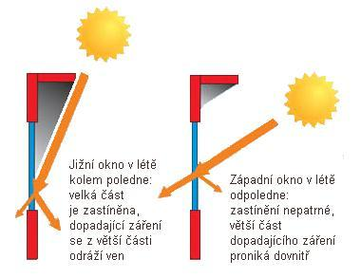are mostly reflected outwards.

Figure 1: Southern and Western glazing (source: EkoWATT o.s.)

The use of glazed atriums, conservatories(winter garden) for the use of solar energy is possible, but only after a careful examination of their properties in favor of the building throughout the year. Conservatories have to save energy, bring a bit of nature into the house and expand the living space. However, the main benefit of the winter garden is to improve the quality of the living. If this saves energy, it is rather rated as an additional plus. As it turns out that the conservatories are not necessary for a low energy house, they often abandon their realization.

A large number of low-energy family houses are designed without a basement. A number of technical and energy complications will be dropped and the construction will usually be cheaper. However, if the investor maintains the basement, he would prefer to get an unheated space with a separate entrance outside the heated part of the house. Best when there is a separate entrance from the outside or from an unheated vestibule, so as to avoid as much as possible heat leakage from the main areas of the house. It is not necessary for unheated spaces (garage, storage, chamber, etc.) to create a buffer zone on the north side of the house. The partitions to these spaces must be isolated almost as well as the outer walls.

**Thermal storage properties of perimeter structures**

Another criterion is the thermal storage properties of the perimeter structures. A heavy material building exhibits a slower drop in indoor air temperature and internal surface temperatures than a house with lightweight perimeter structures (e.g. wood buildings) when heating is interrupted. In a massive family house from fittings from the KMB SENDWIX1 system, Novák reports the results of measuring the decrease of the indoor air temperature during interrupted heating. At night outside temperature of 7 ° C for 12 hours, the indoor air temperature drops from 21 ° C to only 20.4 ° C. Such a house will also be able to translate several days of repeated night temperature drops or morning ground freezing without any problem, without having to start the heating system of the building. This, of course, means considerable savings in energy, cost and often unnecessary worries. At the same house built from lightweight structures (aerated concrete, wood buildings, hollow burnt blocks, etc.), the internal air temperature and internal surface temperatures in the interior drop below the acceptable limit already after 3-5 hours. For such types of houses it is necessary to ensure continuous heating, virtually without heating breaks.

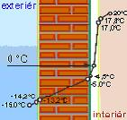 **Figure 2: Comparison of temperatures in the construction of the DTI from the inside and outside of the structure (source: EkoWATT o.s.)**

**Other aspects incl. heating**

Very high requirements for materials are also the high degree of non-combustible and noise protection. Great emphasis should be placed on the acoustic properties of the materials. The ever-increasing audio load is spreading all the time thanks to rising car traffic. When evaluating acoustic insulation measurements, it is necessary to take into account the fact that the human ear does not perceive changes in the noise level as well as the measurement technique (i.e. linearly) - for example, at a noise level of 72 dB, which is out in the street, the human ear perceives a mere 3 dB such as a half-intensity noise drop and a 6 dB attenuation as a drop in quarter-volume noise. This implies that each subtracted decibel (dB) is very important for the subjective perception of the decrease in noise intensity

The next step in reducing the energy consumption for heating a house is to choose the right heating system. Firstly, the heat source has to correspond to the heat losses of the building, and secondly, the heating system must be equipped with an effective control system to ensure not only overheating of the rooms (it is generally known that 1 ° above the required indoor air temperature means an increase in heating energy consumption by 6%). Where there are conditions for the use of the heat of the environment, a heat pump should be part of the heating system. Heat environments are heat of the outside air, heat of water sources (ground water, watercourses or reservoirs) or heat of ground layers below the freezing depth. The amount of energy saved is determined by the heating factor of the heat pump, which gives the ratio between the energy produced and the input power. Average heat pumps have heating factor "3" and peak to "5".

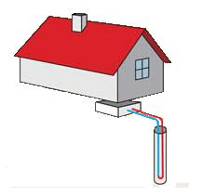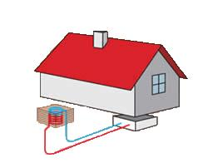E.g. when heating a building by a heat pump to an electric current that collects heat from the ground collector, up to 70% of the electricity can be saved. [5]

Figure 3: Air / water heat pump (source: EkoWATT o.s.)

Figure 4: Heat pump ground / water (source: EkoWATT o.s.)

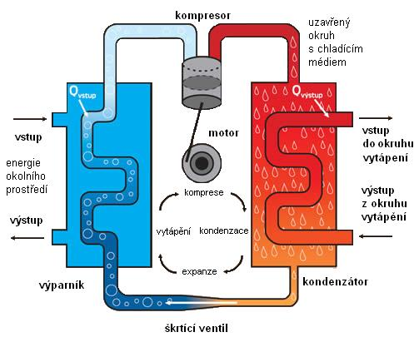

Figure 5: Heat pump principle (source: EkoWATT o.s.)

The cost of building a heat pump is about 120,000 crowns higher than that of conventional heat generators. These additional costs should be amortized over a few years due to maintenance-free operation and approximately 30% lower heat bills. However, this only applies to new constructions. The additional purchase of a heat pump is no longer so economical, and all aspects need to be considered. For existing buildings, it is necessary to perform additional thermal insulation of the structures, which result in thermal losses, including the reduction of heat losses through the fillings of the openings.

• For existing buildings, a fuel and chimney stack has already been built, so construction costs can´t be saved - this increases the cost.

• Costs for the remediation of the chimney are missing

• The space originally intended for storage can later be used as another room or sauna.

• Heat pumps work more efficiently where there is a large heat transfer surface, suitable for underfloor heating with efficient controllers.

• However, the installation of underfloor heating in the old buildings is usually a failure of the construction site or high investment costs. Instead of mounting the floor heating, it is sufficient to replace the bodies that have a room thermostat with a timer. This allows you to program the temperature reduction in the desired period - at night or in the house

Low energy houses are the dominant heat losses of windows and exterior doors. At present, windows and doors with insulating double glazing or triple glazing are available. Since the triple-glazing is about 20% less light than double glazing and their weight is considerably higher, the insulating gas-filled double-glazed windows with a selective coating applied to the surface of the glass are predominantly used in current windows. The most widespread types of windows and exterior doors are windows made of plastic profiles and glued wooden profiles. For plastic profiles, the number of three chambers increased to 5-7. This significantly reduced heat leakage through window frames. In insulating double glazing, connecting frames also have a significant effect on window heat losses. Original aluminum frames are replaced with stainless steel or plastic frames.

**Highest heat losses**

The highest heat losses in current and low-energy buildings are caused by air exchange in the rooms. According to hygienic regulations, permanent air exchange in living rooms should reach 0.5 l / h, that is, one hour should replace half the volume of air in the room. Heat losses through natural air exchange account for up to 70% of total heat losses. It is a big mistake to rely on new window types for natural exchange by leakage of joints between window wings and frames. Simultaneously used windows are almost hermetic in this respect and, in the case of insufficient ventilation, the surface is condensed and molded.

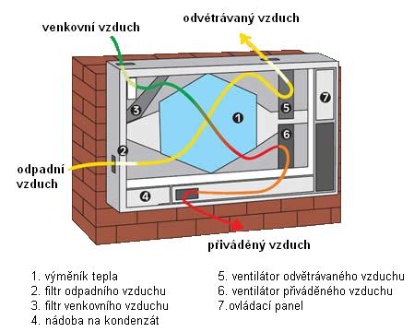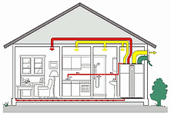In order to ensure a healthy environment in apartments with tight windows, heat recovery from the exhaust air is proposed. The exhausted warm air is exhausted from the room and the fresh air is heated by the heat exchanger, which is fired into the rooms. Recuperative exchangers operate up to 80% efficiency and the outside air is heated up to + 10 ° C by heat recovery exchangers.

Figure 6: Scheme of wall-mounted heat exchanger and ventilation system (source: EkoWATT o.s.)

We can say that all of these parameters are significant, but that we can´t always all of them influence them, yet we should deal with them.

In order for companies that have chosen to penetrate the market for low-energy houses to be competitive and competitive, it is necessary to propose such solutions for buildings in order to achieve the demand for low energy efficiency efficiently, namely with a low investment cost and a small burden on the environment, throughout the life cycle of the building. The resulting energy properties of a building can best be influenced in the preparatory phase of the project. Especially by ensuring optimal connections between the thermal and technical properties of the structures, the heating system and the operation of the building (ventilation and lighting of the building).

**Conclusion**

The issue is quite broad and has been outlined in this article. The questions of the energy efficincy of the building can be seriously answered only by calculating the energy balance of the project object incl. variant solutions - both architectural solutions and a number of austerity measures.

An integral part of this is a comparison of investment and long-term operating costs. Without these calculations, which would take into account the projected development of energy prices in future years, they are only estimates, yet they are a key decision-making aspect.

An economic assessment can be made using a simple return on investment. Simple return is referred to as the cost of implementing the measure and the cost of the saved energy. However, it is more fundamental to use more sophisticated methods.

References

1. *ŠAFRÁNEK, J., Nové poznatky při energetickém hodnocení zděných budov, Sborník přednášek II.ročníku celostátní odborné konference Zděné objekty – snižování energetické náročnosti. Prague: Ediční středisko ČVUT, 2007. ISBN 978-80-239-8902-1.*
2. *TYWONIAK, J., Nízkoenergetické domy. Principy a příklady. Prague: Grada 2005, 2006. ISBN 80-2471-102-8.*
3. *BUER-BOCKLER, H., Ekologická výstavba domů (Nápady a příklady, materiály a provedení. Prague: Euromedia Group – Ikar a Knižní klub, 2000. ISBN 80-7202-696-8.*
4. *EKOWATT o.s.. EkoWatt o.s. - Středisko pro obnovitelné zdroje a úspory energie.* [*www.ekowatt.cz*](http://www.ekowatt.cz)
5. *NOVAK, L., KMB SENDWIX- nízkoenergetický dům od KM Beta. http://stavba.tzb-info.cz*
6. *SVOBODOVÁ, J. Pasivní domy - výzva dneška. http://tzb-info.cz*
7. *TYWONIAK, J. Český instalatér 6/2006, http://tzb-info.cz*
8. *MORÁVEK, P. Stavíme energeticky úsporný dům (X) - Mikroklima nízkoenergetických budov, rekuperace, teplovzdušné vytápění, http://tzb-info.cz*
9. 31/2010/EU. Směrnice o energetické náročnosti budov. 2010
10. SMOLA. J. Stavba a užívání nízkoenergetických a pasivních domů. Prague: Grada Publishing, 2011. 352s. ISBN 978-80-247-2995-4.
11. ŠUBRT, R. a kolektiv. Tepelné mosty pro nízkoenergetické a pasivní domy. Prague: Grada Publishing, 2011. 222s. ISBN 978-80-247-4059-1
12. Vyhláška č.78/2013Sb. O energetické náročnosti budov
13. UFFELEN, Ch. Passive Houses. Energy efficient homes. Salenstein : Braun Publishing, 2012. ISBN 978-3-03768-106-0.
14. ČSN 73 0540-2. Tepelná ochrana budov – Část 2: Požadavky. 11/2011.
15. KEPPL, J. Podmienky pre návrh zdravého domu, Eurostav 1-2/2015: 12-15, 2015