Construction Maeconomics Conference 2016

Estimate cost of construction in the Czech Republic

Stanislav Vitásek

Department of Economics and Management in Civil Engineering, Czech Technical University in Prague, Thakurova 7/2077, Prague 166 29, Czech Republic

Abstract

The article is about statistical index calculations and about the determination of the detailed estimate cost precision of the construction, while using the usual tools to estimate the price for the development. Statistical input calculations are based upon the data basis of thirty apartment buildings, constructed by twelve different developers. Seventy percent of the apartment buildings were finished in the year 2015 and the rest in 2014. Probabilistic model represents the second option, how to evaluate given issues in this area. This model is based on the risks detected by the Delphi Method, and in cooperation with the representatives of the main developing companies in Czech Republic. We will determine the specific statistical quantities of the recently completed buildings and a degree of probability with which we are able to keep the detailed estimate of construction cost. The article, therefore brings the realistic view, how we work with the costs in Czech development industry and its determined primary for the developers, to help them with the economic strategy, and with the proposals, how to increase the probability of meeting the detailed estimate of construction cost.

Keywords

Construction; Estimate Cost; Probability; Statistics.

Introduction

Every developer wants to have full control over the costs, in order to function properly. In comparison with the other industries, in construction every product (building) is unique. That is why, it is so difficult to determine the costs precisely right from the beginning in the creation phase. Even with the most modern instruments, we are not able to calculate and abide the costs given by the design, at the end of the construction. [1] We can try to find the ways, which will help us to get as close as possible to the detailed estimate of construction cost. The article works with the data from recently finished apartment buildings with the price from 700 000 EUR to little more than 2 000 000 EUR. Seventy percent of the buildings were finished in the year 2015 and the rest in 2014. Almost in all cases the buildings were constructed with concrete, monolithic carrier construction, bricked up with ceramic blocks and flat roof. Desired data were obtained from the top representatives of the development companies in Czech Republic (CR). We picked several top representatives to state the highest risks in development, that influence the difference between the costs at the beginning and at the end of the project. Czech development companies were not willing to give such a sensitive information, however they did so, after a certain pressure from Academia of CR. Information obtained this way, will be processed in different statistical techniques and used in probability model. The results from the statistical part are mapping the current state of the work with costs in CR. The probability model itself, based on the highest risks information is setting the percentage rate of probability, how precise we can be, in the cost settings while designing the project.

The article is only about the expenditure, from the point of the general supplier view while developing the project in private sector. The detailed estimate of construction cost of the project is a term representing the total costs of the development with an adequate profit for the constructor. [2] This includes only the costs for the construction of the future object, it excludes the costs for the land, tax etc. This price could be included in the contract. The price in the contract, can be adjusted, because of the other competitors, the investor's pressure etc. In this research were applied just these expenditure costs, which serve as a basis for the contract. The developers calculate the expenditure costs themselves, in order to set the total costs for the project. To set such a price we use a construction budget in CR, which is a base on the structure of the pricing systems. These pricing systems are processed by the private companies and published in the pricing software. These are prices for specific construction works, and they should serve as a foundation for comparison between these prices and in-house calculations of the construction works. Unfortunately, Czech developing environment is not very rigorous in this aspect and the companies are adjusting only the offered values in the pricing systems. These inaccuracies are causing just the differences between the detailed estimate of construction cost and realization.

Risks and the cost price for the construction work

The construction in CR has got its unique risks, those should be taken in consideration, while preparing the cost price. Their evaluation and inclusion in the contract of construction is individual and each company has got its own system how to work with them. This chapter is dedicated to identify such risks, influencing the difference between the detailed estimate of construction cost and real price the most. The risks are usually presented as the threat negatively influencing result of the project. This article works with the risk, that could work just the opposite way. The final cost price for the construction could be lower than the cost price from the design.

The Delphi Method was used to pick specific risks. This expert method works with group of specialists, they are independently trying to find solutions. [3] The specialist participating in this research are from the companies that gave the data information necessary for this article. Those twelve medium-sized companies have got annual turnover to 40 000 000 EUR each. The respondents should map and evaluate the biggest risks bonded to construction and the price cost compliance from the design. The respondents evaluated specific risks according to their impact, on the scale from 1 to 10, from insignificant to unacceptable and percentage probability of their appearance. Based on this research we were able to determine five most important risks:

* Inadequate project documentation
* Incorrectly calculated construction budget
* Failure to comply with conditions and stolidity in the contract of development
* Appearance of extra-works, or less-works
* Subcontractors

The results of the research are summarized below on the Fig. 1, where you can find the matrix evaluation of the risks. The most influential risks in this matter, were identified as “incorrectly calculated construction budget” and the cooperation with the “subcontractors”. The “incorrectly calculated construction budget” could be caused by wrong calculation, or because of the incorrect bill of quantities and this leads to wrong orders during the realization, confusions while creating work statements, price distortions, and unwanted advancements for one side of the contract.

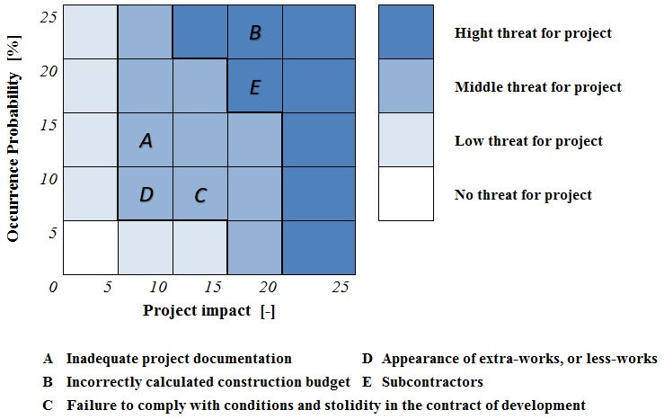Figure 1: Matrix of risks (own research)

The second most influential risk is the cooperation with the subcontractors. Majority of the medium-sized companies in CR are using the subcontractors in more parts of the project. The general contractor is renting the subcontractors for the works, that cannot be done by using own resources. This could be caused by the absence of necessary qualification or inadequate capacity. It’s mainly the craft – works. During the realization of the project is common to inquire repeatedly the subcontractors. The result of such a process is usually the decrease of the detailed estimate of construction cost.

Statistics and the estimate cost for the construction work

The best way to analyze current situation in CR is to use statistical data. The data needed for creation of the statistical models are very difficult to obtain. Fortunately, after the pressure of Academia on the right representatives of the companies, the data on total of thirty buildings were released from twelve construction companies. These were apartment buildings with the size of enclosed area from 5 000 m3 to 13 000 m3, which were finished in the years 2014 and 2015, in the range from 700 000 EUR to little more than 2 000 000 EUR. Most of these buildings are based on concrete monolithic skeleton, filled with ceramic bricks and flat top.

Table 1: Percentage of the detailed estimate of construction cost compliance.

|  |  |  |  |  |
| --- | --- | --- | --- | --- |
| Reached value of the detailed estimate of construction cost [%] | | | | |
| 75,52 | 84,01 | 105,00 | 85,02 | 88,01 |
| 95,01 | 90,99 | 84,00 | 104,00 | 87,00 |
| 94,02 | 84,01 | 88,00 | 114,99 | 102,99 |
| 95,00 | 85,99 | 83,00 | 94,00 | 93,99 |
| 85,00 | 83,00 | 84,01 | 106,02 | 92,01 |
| 88,99 | 88,00 | 96,00 | 92,01 | 94,01 |

Tab. 1 summarizes the results of the data, released by the construction companies. From the data obtained above, it is obvious, that construction companies are rather successful, placing great reserves in their budgets. For instance, if the detailed estimate of construction cost was 925 000 EUR and the cost after realization was 740 000 EUR, the result is eighty percent observance of the detailed estimate of construction cost. It is up to contract conditions between the investor and the main supplier, how will they deal with those differences between each other. Only in five cases out of thirty, the detailed estimate of construction cost has been exceeded. Further in thirteen buildings out of thirty, therefore every third object were not able to construct in compliance with the detailed estimate of construction cost for more than ten percent. The arithmetic average of all achieved detailed estimate of construction cost (Tab.1) is about ninety-two percent.

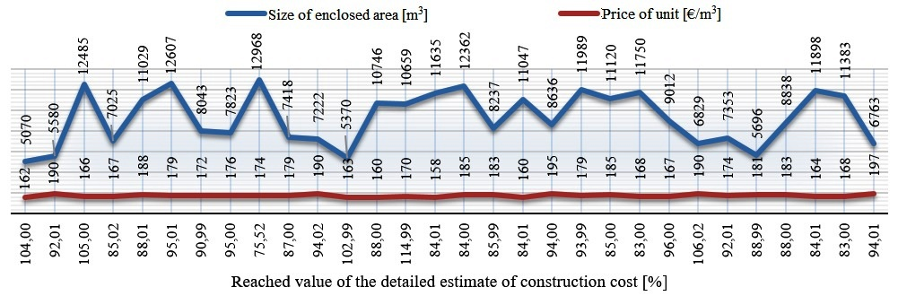Figure 2: The detailed estimate of construction cost compliance according to enclosed area.

Relation between the detailed estimate of construction cost and the size of the building and its percentage value is displayed in picture Fig. 2. From this information it is obvious, that for larger buildings, the percentage value of the detailed estimate of construction cost decreases. Simply, as the enclosed area grows, the percentage value of the detailed estimate of construction cost decreases. The Picture (Fig. 2) shows the graph with the financially calculated data, for the price of 1 m3 of the enclosed area. In the data we can find, that the price for 1 m3 of the apartment house in CR does not have a direct connection with the size of the construction and it is around 176 EUR.

The ability to comply with the detailed estimate of construction cost is considered as the right sign of good work with the costs in any construction company. So far, there is not any generally accepted limits, determining the acceptable values. The construction companies in CR should try to achieve maximum of +- five percent difference between the price from the detailed estimate of construction cost and after the realization of the construction. This boundary is taken in international publications as the difference between success or failure in this kind of ground constructions. [1]

Probability and the detailed estimate cost for construction work

Probabilistic model is focused on the specific probability value determination, with which we are able to determine the real price after the realization of the construction development in its design in CR. Resulted probability value is compared in last chapter with the arithmetic average of already built buildings obtained in chapter 3 and this should evaluate the disinterested accuracy of the probabilistic model. As the model house we picked apartment building with concrete monolithic skeleton, filled with ceramic bricks with the enclosed area of 7 200 m3. Software Crystal Ball, will process the simulations, when all above variabilities are inserted. This software is based on the Monte Carlo method. The variable calculations are set for 10 000 simulations.

Main assumptions for probabilistic model

Main entries for the probabilistic model are costs for construction and risks. The estimate of construction cost enters the model as the only fixed value, which is determined by the construction budget on 1 309 656 EUR. This value was determined as the ideal model value according to gathered data. The other variables represent risks obtained from the market survey (chapter 2), which are subject to Stochastic calculation. [4] These risks are summarized and according to their function evaluated in the Tab. 2. The pessimistic scenario substitutes the option for the highest possible exceed of the detailed estimate of construction cost. On the other hand, the optimistic scenario substitutes the lowest possible boundary.

Table 2: Risks and scenarios

|  |  |  |  |  |  |  |
| --- | --- | --- | --- | --- | --- | --- |
| Type of risk | Occurrence Probability | Project impact | Occurrence interval | Optimistic scenario | The most probable scenario | Pessimistic scenario |
| Inadequate project documentation | 13 % | 8 % | (0.90 ; 1.10) | 6 548 € | 13 620 € | 19 645 € |
| Incorrectly calculated construction budget | 22 % | 19 % | (0.95 ; 1.15) | 39 290 € | 54 744 € | 65 483 € |
| Failure to comply with conditions and stolidity in the contract of development | 6 % | 12 % | (1.00 ; 1.20) | 6 548 € | 9 430 € | 19 645 € |
| Appearance of extra-works, or less-works | 9 % | 9 % | (0.85 ; 1.05) | 3 274 € | 10 608 € | 13 097 |
| Subcontractors | 20 % | 17 % | (0.75 ; 0.95) | 39 290 € | 44 528 € | 65 483 € |

Apart from the common risk aspects, therefore the size of impact and the probability of appearance, respondents had an option to state so called occurrence interval. This variability goal in the probabilistic model is to substitute an option, when risk does not have to influence the cost only negatively, that means increase. It may as well decrease the estimate cost, which is apparent from the obtained data in the chapter Statistics and the Estimate Cost for the Construction Work. The occurrence interval is designed the way, it could stimulate evaluate risks in the most probable direction. For example, in the incorrectly created construction budget, this interval represents rather the possibility of the increase of the detailed estimate of construction cost, during its realization. The interval enters the calculations in the probabilistic model. The evaluation of the risk itself in given scenario is determined by the general function [5]:

Risk evaluation= occurrence probability . project impact . construction costs (budget) (1)

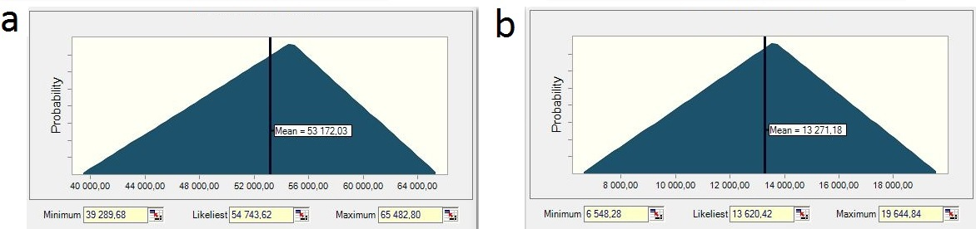The probability distributions for all the risks was determined as triangular, according to the format of the obtained data. This probability distribution is defined by three parameters. The top of triangle represents the density for the most probable scenario, which is represented by specific number. In our model it is the value, we obtained in the market survey. The bottoms of the triangle are presenting low and top limits. Those values are determined by the boundaries visible in the Matrix of risks (Fig. 1), at the same time these bottoms are determined optimistic and pessimistic scenarios. The triangular determination example with the actual data is displayed below (Fig. 3) for the risks with the biggest influence on the estimate of construction cost.

Figure 3: Triangular distribution- (a) incorrectly calculated construction budget; (b) inadequate project documentation

Evaluation of the probability model

The evaluation of the probability model, which is based on the obtained data from the Czech construction market area is graphically displayed on the picture Fig. 4. The graph shows that there is a ninety percent probability that the estimate cost of construction price from the proposal will not be exceeded. This percentage border is closer to statistical results, which determined that five houses out of thirty shall exceed detailed estimate of construction cost. This is represented by the value of eighty-three percent, the difference is therefore seven percent. For this specific case expressed in money as nearly less than 90 000 EUR. This deviation might be interpreted as satisfactory concerning the form of the gathered data. At that time, we might state that statistical data are confirming the validity of the probability model and vice versa.

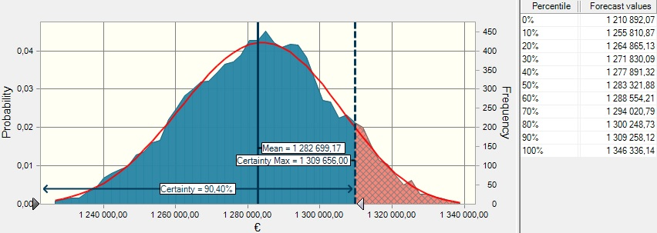Figure 4: Probability of keeping the detailed estimate of construction cost

For the probability model there was further elaborated sensitive analysis, which defined percentage probability of the possibility of affecting the detailed estimate of construction cost. The result of the sensitive analysis is graphically represented below (Fig. 5), where were confirmed obvious data.

Figure 5: Sensitive analysis of model only with risks

Therefore, that among the most influential risks belongs incorrectly designed construction budget and the works with the subcontractors. Each of those risks reached nearly four percent share on possible affection of the detailed estimate of construction cost for the specific construction model.

Conclusion

The accuracy of the determination of the costs from the proposal and then their keeping are indicators of the correct work with the costs in any construction company. Executed research determined the specific percentage value of keeping the detailed estimate of construction cost. It was determined from the database of thirty apartment houses, that arithmetic average of reaching detailed estimate of construction cost is approximately ninety-two percent. Another statistic value is bringing the finding, that the percentage value of keeping the detailed estimate of construction cost is decreasing when the volume of enclosed area of the apartment house is increasing. Only thirteen constructions out of thirty, therefore one third of the constructions, exceeded detailed estimate of construction cost for more than ten percent. The last important number is the amount 176 €/m3 of enclosed area, where the direct interconnection between the price for 1 m3 and the size of the building has not been proven. Those indicators are reflecting real work with the costs in medium-sized construction companies in CR. It is of course, very difficult to determine the limit of acceptable deviations and it is impossible to apply it generally. Until now, there is no generally valid strict limit in Czech Republic, which would determine which values were acceptable and which weren't. The correct goal for the Czech construction industry is to close as much as possible to +- five percent difference between the detailed estimate of construction cost and after the construction works realization. The same difference, as it is, in developed countries. On the other side, it is not quite bad to reach more than ninety-two percent average of keeping detailed estimate of construction cost, considering all existing risks. With increasing pressure on the costs optimization and competition it is obvious, that percentage deviation from detailed estimate of construction cost shall be further decreasing.

In the second part of the research we applied the probability model in order to determine the probability of keeping detailed estimate of construction cost with the help of risks on the type apartment house. This model determined, that with ninety percent probability will not be exceeded the detailed estimate of construction cost. This percentage border is closing to statistic results, which determined that five houses out of thirty shall exceed detailed estimate of construction cost. This represents the value approximately eighty-three percent. The difference is thus approximately seven percent. This might lead to conclusion, that gathered data are quite realistic and they mutually support their validity. Following sensitive analysis confirmed dominant position of risks of incorrectly designed detailed estimate of construction cost and works with sub suppliers. By decreasing of thirteen percent of probability of occurrence of the risk of incorrectly designed detailed estimate of construction cost from considering twenty-two to nine, shall the probability of not exceeding of detailed estimate of construction cost increase by five percent to a total ninety-five. This represents proposed limit for the successful project in the modern world.

Proposals of measures related with the application of reachable tools, which purpose is to decrease the probability of not keeping detailed estimate of construction cost, aren't sadly commonly available. The error rate in construction budgets represents ideal representative for using complex tools based on Build Information Modeling (BIM). The generating of acreages together with referencing the construction agents to respective price systems, until now existing rather in different aggregates, are substantially facilitating and refining the work of estimator. Thus also the costs of construction work. As the second most risk factor was evaluated the work with subcontractors. Sadly, the prevailing criteria during the selection of the subcontractor for the chosen construction works is still the lowest price for the realized works. Possible solution is based on acceptance of higher prices for realized works, which might reach the real prices determined in detailed estimate of construction cost and thus might bring to the construction process superior subcontractors. And further to cooperate with companies with which we have good experience for a long time.

The biggest contribution for the accuracy of determination of costs in the proposal we expect from the models based on BIM. Processing of this technology shall enhance not only the accuracy of the costs determination in the proposal, but also the competitiveness and credibility from the perspective of the investor. Sadly, in CR there are still missing enough representative samples to realize superior research and to confirm hypothesis about elimination of the dominant factor – errors in the construction budget.

Acknowledgements

This work was supported by the Grant Agency of the Czech Technical University in Prague, grant No. SGS16/026/OHK1/1T/11

References

1. WHYTE, Andrew. *Integrated design and cost management for civil engineers*. Boca Raton: CRC Press/Taylor, 2015. ISBN 978-041-5809-214.
2. BALDWIN, A, Ronald MCCAFFER a Sherif OTEIFA. *International bid preparation*. Geneva: International Labour Office, 1995. ISBN 92-210-8752-2.
3. CRETU, Ovidiu, Robert STEWART a Terry BERENDS. *Risk management for design and construction*. Hoboken, N.J.: RSMeans, c2011. ISBN 047063538X.
4. WILLIAMS, Peter. *Managing measurement risk in building and civil engineering*. Hoboken, NJ: John Wiley, 2015. ISBN 978-111-8561-522.
5. BENJAMIN, Jack R a C CORNELL. *Probability, statistics, and decision for civil engineers*. Dover edition. Mineola, New York: Dover Publications, Inc., 2014. ISBN 04-867-8072-4.