Construction Maeconomics Conference 2020

Utilization of UML Modeling in Construction Procurement

Martin Stránský1

1Czech Technical University in Prague, Faculty of Civil Engineering, Department of Construction Management and Economics, Thákurova 2077/7, Prague, 166 29, Czech Republic

martin.stransky@fsv.cvut.cz

Abstract

This paper utilizes UML modeling for the purpose of describing possible innovation in procurement processes within construction projects. Described and modeled procurement processes are a part of procuring a general contractor by a client with the focus on general contractor’s processes. However, other actor’s processes are also presented. At first possible scenarios of proposed model’s ownership are presented and discussed. The scope of paper takes into consideration only one scenario. Then all actors participating in the procurement process are identified. During the analysis of current procurement processes two types of actors were identified. One type of actors are real humans, who participate in procurement process. The second type are virtual actors, who enable real humans interact with the proposed model. Relationships between all identified actors is described and presented by UML relationships diagram. At last use cases for all identified actors are listed and described, use cases related to general contractor are listed, described and presented by UML use case diagrams.

Keywords

construction; digitalization; procurement; UML modeling

Introduction

Based on previous author’s research [1]–[4] the author started to work on possible future innovation of procurement process of subcontractors within the construction industry. Author identified two main phases of project’s procurement and one subphase, where some project stakeholders are already contractual partners and other project stakeholders are competing to become contractual partners. Contractual partners are considered as users of proposed model and competing project stakeholders are not considered as users of proposed model.

The first identified phase is when a client is procuring a general contractor. The second identified phase is when a general contractor is already awarded the project and he is procuring subcontractors. A subphase of the second phase is when some subcontractors were already awarded a contract.

This paper is focused on the first phase when client is procuring a general contractor. Author identified four scenarios of proposed model ownership. Focus of this paper regarding identified scenarios will be described further in the paper. Selected procurement route is Design and Build (DB), where general contractor will be responsible for construction and design of a project during the construction phase. However, this fact will play a major role during the construction phase not in the phase of procuring a general contractor.

The aim of this paper is to present and describe actors participating in the procurement process, their relationships and their use cases by modeling UML diagrams.

The problem that the author is trying to avoid, is to store correspondence with subcontractors participating in a tender and the tender documentation separated in several IT systems. Hence functions of a model are proposed to enable procurement managers of general contractors conduct and manage procurement of subcontractors in this model.

The Unified Modeling Language (UML) is a standard visual modeling language and is a common language for business analysts, software architects and developers used to describe, specify, design, and document existing or new business processes. [5] Its first version 1.1 was released in November 1997. [5] UML consists of actors, use cases and other components. An actor is behaviored classifier which specifies a role played by an external entity that interacts with the system. [6] Use cases allow to capture requirements of systems under design or consideration, describe functionality provided by those systems, and determine the requirements the systems pose on their environment. [7] Actors, their relationships and their use cases are represented in UML use case diagrams. Use case diagrams are usually referred to as behavior diagrams used to describe a set of actions (use cases) that some system or systems should or can perform in collaboration with one or more external users of the system (actors). [8]

Methodology

The methods how results were obtained are following:

* analysis of current procurement processes of subcontractors,
* analysis of current IT model’s functions supporting procurement processes,
* author’s innovation of functions that support procurement processes,
* research of UML diagrams,
* modeling of UML diagrams.

Analysis of current procurement processes of subcontractors and analysis of current IT model’s functions supporting procurement processes were conducted in authors prior publications [2-4].

Results

At first four identified scenarios of model’s ownership will be presented, with the specification of selected scenario for this paper. Later identified actors participating in procurement process will be presented. Then relationships between identified actors will be presented. At last actor’s corresponding use cases will be presented and described.

Model’s ownership scenarios

Author identified four model’s ownership scenarios, where model is owned by various project stakeholders. In two scenarios model is owned only by one project stakeholder in other two scenarios two project stakeholders own their models.

First scenario

In the first scenario client owns his model and general contractors are willing to import their data and set of rules into client’s model and work completely within client’s model. As general contractors are not usually offered with enough time to work out their bids, this scenario would most likely not be feasible for them. As well as general contractors might not be willing to import their business know-how into a model owned by a client. There would need to be a private part of the model, where each project stakeholder could keep his data secure and not shared with other project stakeholders.

Second scenario

In the second scenario client owns his model and general contractors own their models. General contractors import client’s data into their models, from where they send requests for quotation (RFQ) to subcontractors. At the same time general contractors have to work with the client in his model, to place their questions, comments and submit their bids. Disadvantage is that, if data in client’s model are updated then data in general contractor’s model have to be manually updated as well. However, this could be solved by an API or by standardizing the data so they could be transferred automatically. Advantage is that general contractors keep their business know-how in their models.

Third scenario

The third scenario is similar to the second scenario, the only difference is that general contractors do not import client’s data into their model. Data are left in client’s model from where they are shared with subcontractors. Disadvantage is that as subcontractors are not registered users of client’s model, general contractors have to send notification about any update of data to their subcontractors. Advantage is that general contractors keep their business know-how in their models.

Fourth scenario

In the fourth scenario client owns no model, hence general contractors have to own their models, where they can completely work with the client. As this would require the client to work in many models, this scenario is unlikely to occur in the phase of procuring general contractor. This scenario is more likely to occur during the construction phase, where selected general contractor/s provide his/their model.

This paper will focus on the second scenario where client owns his model as well as general contractors own their models. However, it is not impossible that there would only be one common model. It is question of data migration and of legal conditions as well as of security of data, because no one would like to share his business know-how with other project stakeholders without profiting from it.

Actors

During the analysis of current procurement processes two types of actors were identified. The first type of identified actors are real humans, who interact with the proposed model and therefore participate in the procurement process. The second type of identified actors are virtual, that is why they are internal part of the proposed model and enable real humans interact with it. The first type of identified actors will be further referred as project stakeholders, the second type of identified actors will be further referred as model components.

Project stakeholders consist of following actors:

* Client – abbreviation CL
* General contractor – abbreviation GC
* Subcontractor – abbreviation SUB
* Sub-subcontractor – abbreviation SUB-SUB

As mentioned before project stakeholders represent real humans, who take active role in the procurement processes. Each of the project stakeholder has specific use cases, which enable them to manage their relevant procurement processes within the proposed model. Use cases will be further described in following chapters.

Model components consist of following actors:

* User
* System

As already mentioned, both system and user allow project stakeholders to manage their procurement processes within the proposed model. They are internal parts of the proposed model and empower project stakeholders to conduct their processes in a seamless way.

User is an elementary component of the proposed model, because its use cases are inherited by all children actors of the proposed model. Basically, being a user allows project stakeholders register, login and work within the proposed model. Unregistered project stakeholders can conduct limited number of use cases within the proposed model, however, are still allowed to conduct fundamental use cases.

System is a backbone of the proposed model, which provides project stakeholders with important use cases that support their procurement processes and make these processes run seamlessly.

Relationships between identified actors

There is generalization relationship between certain actors, which means that some actors inherit use cases from another actor. That makes the actor from whom they inherit a parent and those who inherit children. User is parent of a CL and a GC, thus are his children. That means that CL and GC are registered users of proposed model. As SUB and SUB-SUB do not inherit from user, they are not registered users of proposed model. Relationships between both types of identified actors are schematically represented in Figure 1 by an UML actor’s relationships diagram.

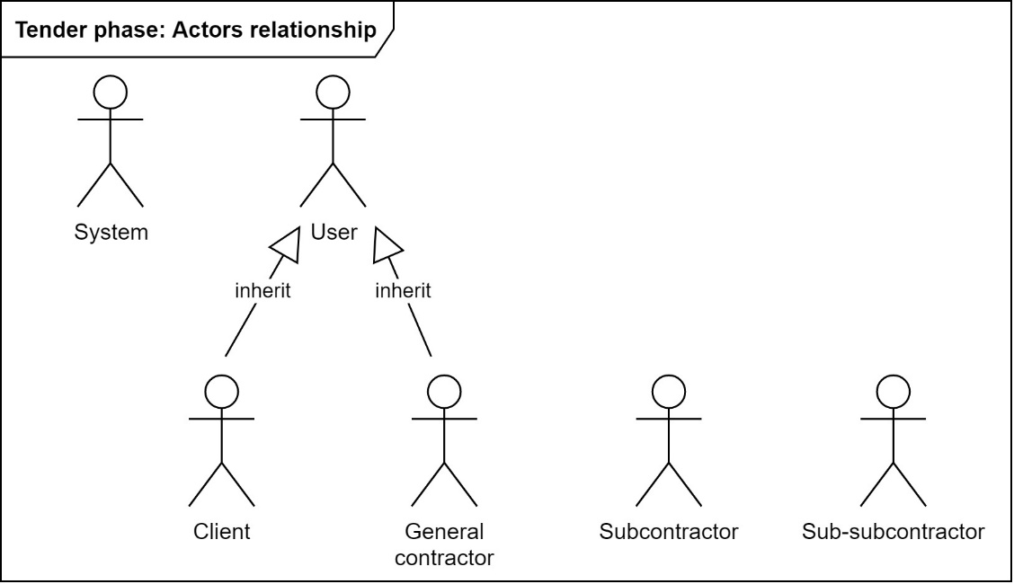

Figure 1. UML relationships diagram of actors (source: Author)

Use cases (UC)

Despite six actors were identified only UML use case diagrams related to GC’s procurement process will be presented. Hence, only three UML use case diagrams will be presented in paper. Since focus of this paper is on the second scenario, where GCs work in CL’s model as well as in their own models, GCs will have two UML use case diagrams. One UML use case diagram will present their use cases in CL’s model and the second UML use case diagram will present their use cases in their own models.

User’s use cases

User is a virtual actor and an internal part of the proposed model, who enables real actors to interact with it. User is a parent to registered actors, that is why it enables its children to make use of its use cases.

User’s use cases are following and enable him to do following operations:

* *UC1 Register* – Enable a user to register to the proposed model, fill in his login details and contact details.
* *UC2 Login* – Enable a user to login after entering his correct username and password.
* *UC3 Reset password* – Enable user to reset password in case he has forgotten it.
* *UC4 Send e-mail with a link to reset password –* The system has to react to that and send user an e-mail with instructions how to reset his password.
* *UC5 Update personal login details* – Enable user to update his login details in case they need to be changed.
* *UC6 Update personal contact details* – Enable user to update his contact details in case they need to be changed.

Client’s use cases

CL is a real human and was classified as a project stakeholder. It is a child of a user therefore it inherits his all use cases. That is why, CL is a registered user of the proposed model. As already mentioned during the phase of procuring a GC the CL has his own model, where he processes procurement of GCs in assistance with his contractual consultants and designers.

Client’s use cases are following and enable him to do following operations:

* *UC7 Create and manage database of general contractors* – CL shall have the possibility to create and manage his own database of GCs that he usually invites to tender. This database shall be private and only authorized users shall have access to it.
* *UC8 Create a project* – Enable CL to create a project that he intends to tender.
* *UC9 Upload tender documentation* – Enable CL to upload tender documentation. This will usually be done by his contractual consultants and designers.
* *UC10 Create tender for a project* – Enable CL to create a tender for his project.
* *UC11 Send RFP to general contractors* – Enable CL to send requests for proposal (RFP) to selected GCs from his database of GCs.
* *UC12 Send e-mail notifications to general contractors* – Enable CL to held correspondence with selected GCs in a central point, where it can be shared with appropriate users.
* *UC13 Open submitted bids of general contractors* – As GCs have the possibility to submit their bids within CL’s model, CL shall have possibility to open these submitted bids.
* *UC14 Evaluate bids of general contractors* – Once bids of GCs are opened, CL in cooperation with his contractual consultants and designers shall evaluate submitted bids. Evaluation method is dependent of which evaluation method CL decides to utilize [9].

General contractor’s use cases in client’s model

As far as GC inherits use cases from the user, he will be registered user within CL’s model, where he will participate in the tender for a project. All GC’s use cases in CL’s model and his relationship with the user are schematically represented in Figure 2 by an UML use case diagram.

GC’s use cases in CL’s model are following and enable him to do following operations:

* *UC15* – Enable GC to open tender documentation that was shared by CL.
* *UC16* – Enable GC to send e-mail notifications to CL in case he requires more information.
* *UC17* – Enable GC to submit his bid within the model for CL’s evaluation.

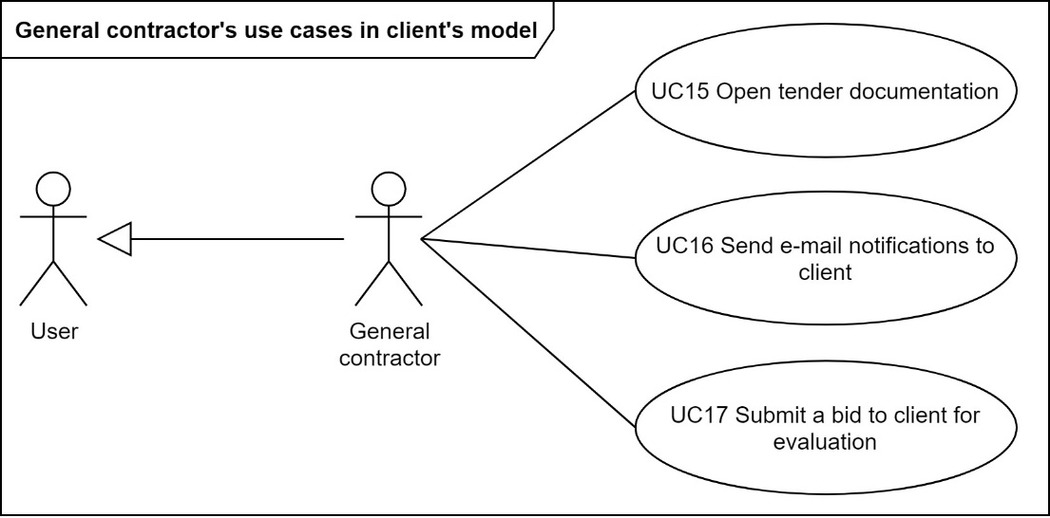

Figure 2. UML use case diagram of general contractor's use cases in client's model (source: Author)

General contractor’s use cases in his model

GC will in this phase use CL’s model as well as his own model. This is predominantly due to short time usually available during the procuring of a GC phase and that GCs might not be willing to share their business know-how without profiting from it, if they would import their data and set of rules into CL’s model. GC also inherits use cases from the user hence he will be a registered user of proposed model. All GC’s use cases in his model and his relationship with the user are schematically represented in Figure 3 by an UML use case diagram.

General contractor’s use cases in his model are following and enable him to do following operations:

* *UC18* – Enable GC to create a project.
* *UC19* – Enable GC to upload project documentation to share it with SUBs.
* *UC20* – Enable GC to create and manage his own database of SUBs that he usually sends RFQ or works with. This database shall be private and only authorized users shall have access to it.
* *UC21* – Enable GC to create and manage SUB’s certificates in the database of SUBs. These certificates might be required due to tender conditions (e.g. LEED certificate, FSC certificate etc.).
* *UC22* – Enable GC to score SUBs based on their behavior during tender and quality of their bids.
* *UC23* – GC shall identify work packages (WP), representing works, materials and services that will need to be delivered to the construction site, based on set of rules. These set of rules shall work with classification system or with BIM model’s object’s parameters.

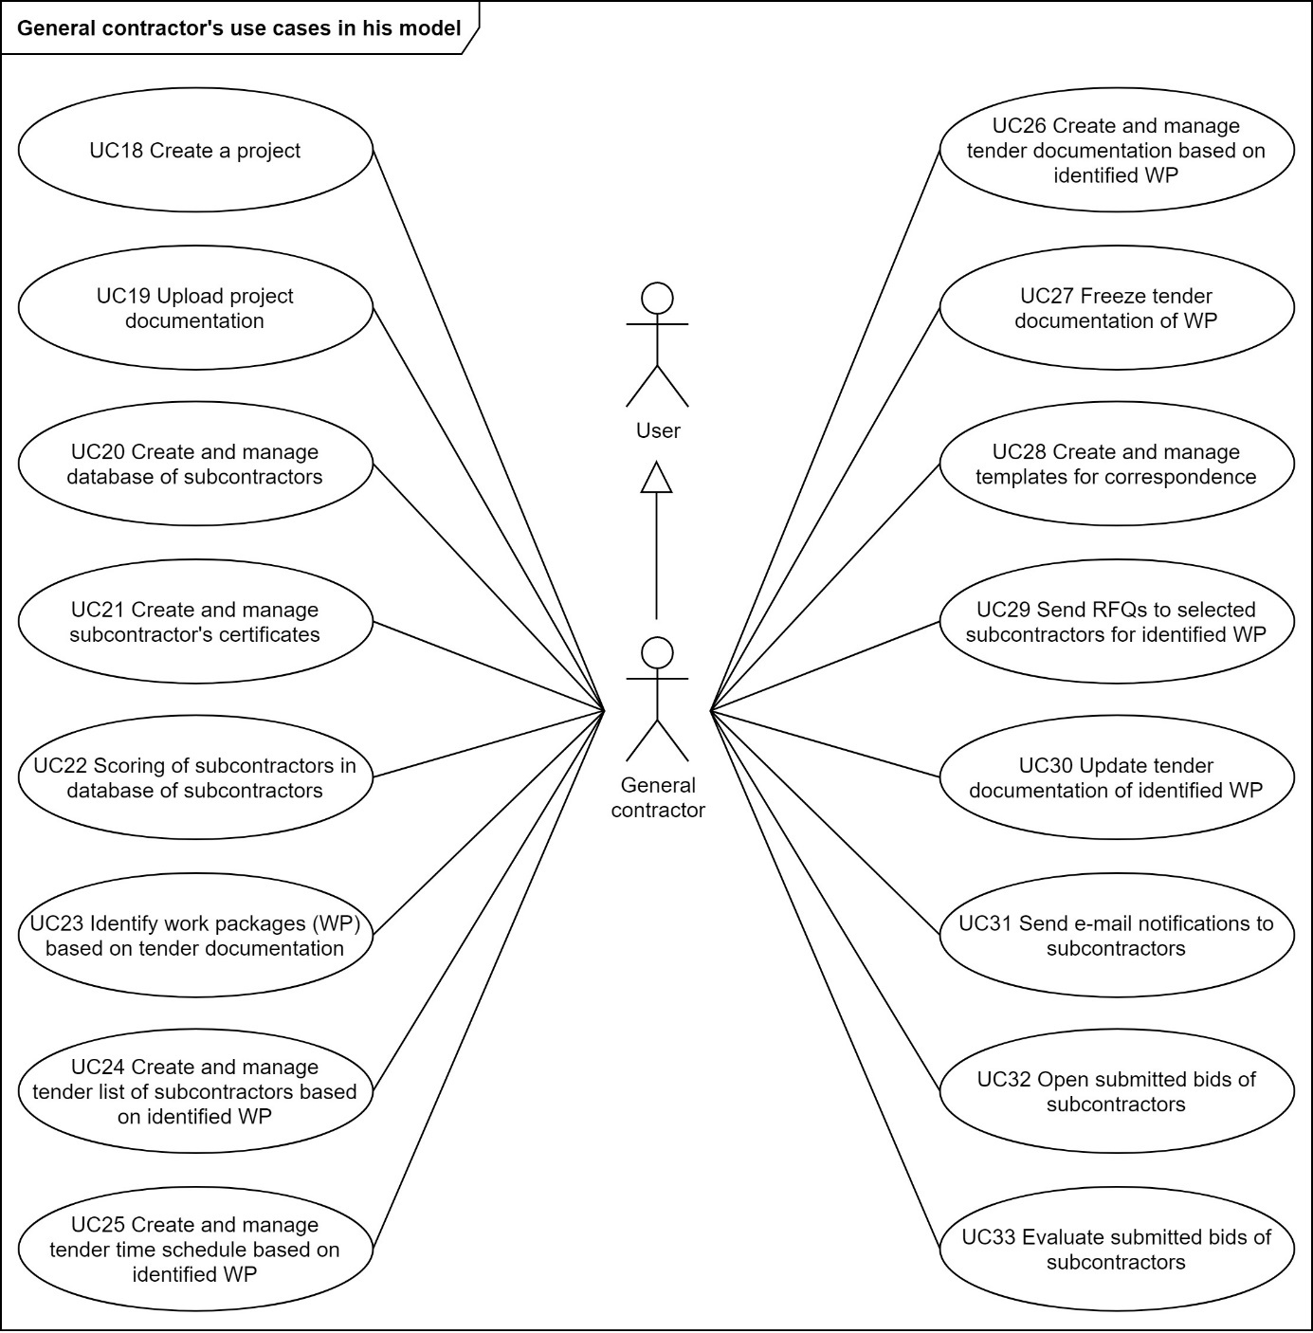

Figure 3. UML use case diagram of general contractor's use cases in his model (source: Author)

* *UC24* – Based on identified WP GC shall create and manage tender list of SUBs that he will send RFQ to.
* *UC25* – As GC is usually provided with not much time to work out his bid, tender time schedule contains only desired date for SUBs to submit their bids and estimated construction period of WP.
* *UC26* – GCs shall divide complete project documentation into partial tender documentation relevant to identified WP.
* *UC27* – GC shall have possibility to freeze partial tender documentation of WP to specific date. This way GC and SUBs will know to which date it is valid.
* *UC28* – GC shall have possibility to create and manage templates of correspondence relevant to all tender phases (RFQ, reminder of RFQ, etc.).
* *UC29* – When GC has partial tender documentation ready then he shall send RFQs to selected SUBs.
* *UC30* – If complete tender documentation is updated then GCs shall update partial tender documentation relevant to identified WP.
* *UC31* – GC shall have the possibility to send SUBs e-mail notifications from a central point, where it can be shared with authorized users. E-mail notification is required at this phase of project because SUBs are not registered users of proposed model.
* *UC32* – After SUBs submit their bids into the model then GC shall have possibility to open submitted bids.
* *UC33* – After opening submitted SUB’s bids, GC shall evaluate these bids and use selected bids for his own bid for the client. Evaluation method is dependent of which evaluation method GC decides to utilize [9].

System’s use cases

System is a virtual actor and an internal part of the proposed model, which enables real actors to interact with it. All system’s use cases are schematically represented in Figure 4 by an UML use case diagram. System’s use cases shall generally make user’s work seamless and easier. They should mainly assist GC to conduct procurement processes of SUBs.

System’s use cases are following and enable it to do following operations:

* *UC34* – Shall continuously validate SUBs details in GC’s database of SUBs with business registers.
* *UC35* – Enable mass import of SUB’s details into the GC’s database of SUBs, if needed to be imported from another model.
* *UC36* – Automatically send e-mail notifications to GC before SUB’s certificate expires.
* *UC37* – Semi-automatically propose identified WP to GC based on GC’s set of rules working with classification system and/or BIM model’s object’s parameters.
* *UC38* – Semi-automatically propose list of SUBs based on matching of identified WP with SUB’s portfolio of works, material and services they can deliver.
* *UC39* – Semi-automatically propose GC partial tender documentation for identified WP.
* *UC40* – Propose users to send a notification when complete or partial tender documentation is updated.
* *UC41* – Propose GC templates of correspondence based on tender phase (e.g. RFQ, reminder, etc.).
* *UC42* – Autofill templates of correspondence with values from proposed model (e.g. tender time schedule, name of identified WP, name of selected SUB, etc.).
* *UC43* – Automatically records certain dates of correspondence (e.g. when SUB sends first reply, when SUB submitted his bid, etc.).
* *UC44* – Propose GC to record dates of tender time schedule (e.g. when SUB send rejection, etc.).
* *UC45* – Synchronize tender documentation to PC and/or mobile devices.
* *UC46* – Automatically generate list of sent partial tender documentation relevant to identified WP. GC can then send this list with other documentation to SUBs. This way both parties will know, which documentation was sent on a certain day. This can also be used in client’s model.
* *UC47* – Automatically generate list of updated partial tender documentation and highlight updated documentation, which makes it easier for both parties know, what had been updated. GC can then send this list with updated documentation to SUBs. This can also be used in client’s model.
* *UC48* – Automatically record, who completely downloaded, viewed partial tender documentation.

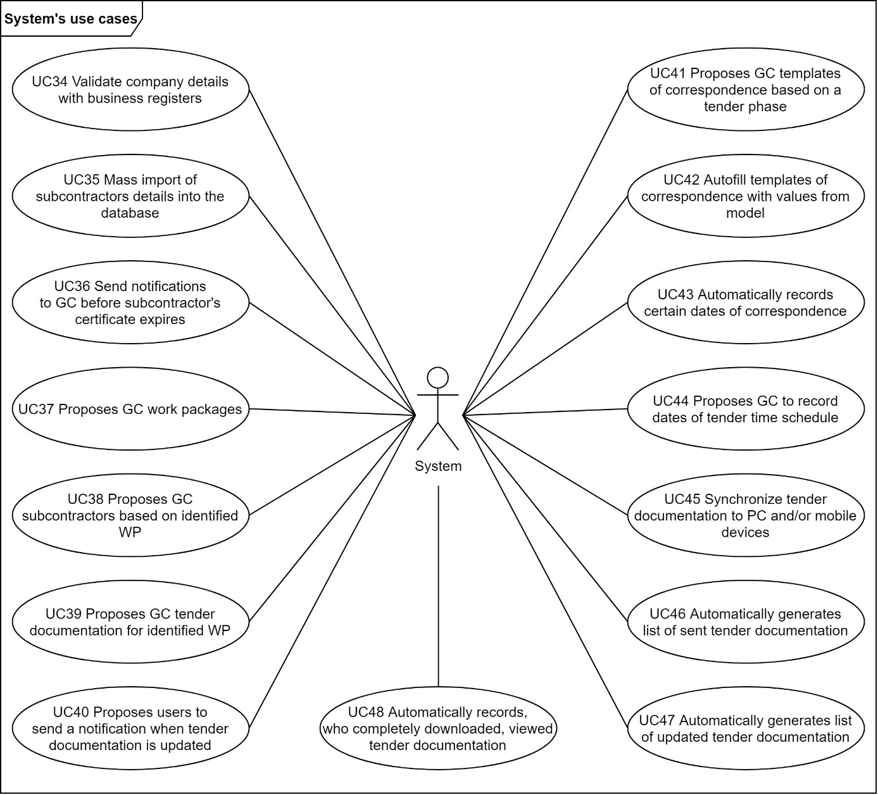

Figure 4. UML use case diagram of System's use cases (source: Author)

Subcontractor’s use cases

SUB do not inherit use cases from a user, that is why he is not a registered user of proposed model.

SUB’s use cases in GC’s model are following and enable him to do following operations:

* *UC49 Open tender documentation of WP* – Enable SUB and SUB-SUB to open partial tender documentation of requested WP.
* *UC50 Share tender documentation of WP with sub-subcontractors* – Enable SUB to share partial tender documentation of requested WP with SUB-SUBs.
* *UC51 Submit a bid to GC for evaluation* – Enable SUB to submit a bid to GC for his evaluation.

Sub-subcontractor’s use cases

SUB-SUB do not inherit use cases from a user, that is why he is not a registered user of proposed model. SUB-SUB shares use case number 49 with the SUB, hence he can also open partial tender documentation of requested WP.

Conclusion and discussion

At first paper presents four scenarios of model’s ownership during the phase when a CL is procuring a GC. Paper focuses on the second scenario, where both CL and GCs have their own models. The reason for that is, that GCs will not have enough time to import their data and set of rules into CL’s model. At the same time GCs might not be willing to share their business know-how at this phase without profiting from it. Then six actors participating in the procurement process are presented. Author identified two types of actors. The first type are real humans, who will interact with the proposed model. The second type are virtual actors, who will enable real humans interact with the proposed model. Later relationships between both types of identified actors are presented by an UML relationships diagram. At last use cases of selected actors are presented by UML use case diagrams.

Aim of this paper, to present and describe actors participating in the procurement process, their relationships and their use cases by modeling UML diagrams, was fulfilled.

Future research should focus on modeling UML activity diagrams of selected use cases and on modeling UML domain diagrams. Also, future research should focus on modeling UML diagrams for procurement processes during construction phase of a project.

Acknowledgement

This work was supported by the Grant Agency of the Czech Technical University in Prague, grant No. SGS20/101/OHK1/2T/11.

References

1. M. Stránský and P. Dlask, “Process of Matching Work Items Between BIM Model and Cost Estimating Software,” presented at the 17th International Scientific Conference Engineering for Rural Development, May 2018, doi: 10.22616/ERDev2018.17.N423.
2. M. Stránský and P. Dlask, “Current Procurement Processes of Subcontractors,” Praha, 2019, Accessed: Dec. 01, 2019. [Online]. Available online at: http://www.conference-cm.com/podklady/history10/Str%C3%A1nsk%C3%BD.docx.
3. M. Stransky, P. Matejka, and J. Kupec, “Process map of current tender processes of subcontractors,” *Bus. IT*, vol. IX, no. 2, Art. no. 2, 2019, doi: 10.14311/bit.2019.02.06.
4. M. Stransky, “Functions of common data environment supporting procurement of subcontractors,” presented at the 19th International Scientific Conference Engineering for Rural Development, May 2020, doi: 10.22616/ERDev.2020.19.TF186.
5. www.uml-diagrams.org, “The Unified Modeling Language.” *uml-diagrams.org,* Available online at: https://www.uml-diagrams.org/ (accessed Oct. 11, 2020).
6. www.uml-diagrams.org, “UML Actor.” *uml-diagrams.org,* https://www.uml-diagrams.org/use-case-actor.html (accessed Oct. 11, 2020).
7. www.uml-diagrams.org, “UML Use Case.” *uml-diagrams.org,* Available online at: https://www.uml-diagrams.org/use-case.html (accessed Oct. 11, 2020).
8. www.uml-diagrams.org, “UML Use Case Diagrams.” *uml-diagrams.org,* Available online at: https://www.uml-diagrams.org/use-case-diagrams.html (accessed Oct. 11, 2020).
9. Designing Buildings Ltd., “Procurement route,” *Designing Buildings*, Available online at: https://www.designingbuildings.co.uk/wiki/Procurement_route (accessed Oct. 11, 2020).